

JOINT INSTITUTE FOR NUCLEAR RESEARCH

Frank Laboratory of Neutron Physics

**FINAL REPORT ON THE**

**INTEREST PROGRAMME**

*Operating with structural information on 1D, 2D, and 3D levels: structure and properties of bioactive compounds*

**Supervisor:**

Dr. Elena V. Raksha

**Student:**

Tanishq Raj, India

Delhi Technological University

**Participation period:**

30 October - 10 December, 2023, Wave 9

Dubna, 2023

**Abstract**

This report presents the results obtained during the realization of a project *‘Operating with structural information on 1D, 2D, and 3D levels: structure and properties of bioactive compounds*’, implemented within the framework of the INTEREST program, JINR. This project explores the structural intricacies of bioactive compounds, focusing on anthraquinone as a main research object. Employing a multidimensional approach, we integrate experimental techniques and data, such as those of X-ray analysis and IR Spectrometry, with quantum chemical methods. Utilizing MOPAC2016, we conduct quantum chemical calculations and generate 3D structural models using ChemSketch Modelling software, unveiling molecular geometry and properties. The significance extends beyond theoretical exploration, as anthraquinone's versatile applications, including those in Li-ion batteries, underscore the practical implications of our findings. The project focuses on bioactive compound characterization along with structural analysis and emphasizes the broader importance of anthraquinone in diverse fields, positioning it as a critical component in both theoretical frameworks and practical applications.

**Introduction**

In the realm of organic chemistry, the structural investigation of compounds serves as a pivotal foundation for understanding molecular arrangements. Employing diverse experimental techniques such as NMR spectroscopy, Mass Spectrometry, and X-ray diffraction, we aim to unveil the spatial organization of organic molecules. Quantum chemical methods enhance our comprehension of electronic structures and thermodynamic properties, while visualization tools like ChemSketch assist in constructing 3D models. This holistic approach, inclusive of Infrared (IR) spectroscopy for vibrational insights, not only deepens theoretical understanding but also holds broad practical implications across fields such as pharmaceuticals and materials science.

The primary objective of this project is to obtain basic knowledge and skills for confidently handling structural information about chemical compounds at 1D, 2D, and 3D levels. The object of study is **anthraquinone** – an organic compound, a representative of quinones. It is widely used as a chemical intermediate for dyes and pigments, an additive in Kraft pulp processing, a catalyst in vegetable oil processing, a sensitizing agent in the photography industry, a potential material for rechargeable batteries; a contributor to polymer synthesis for plastics and adhesives; and an enhancer of color fastness in textiles, cosmetics, and fashion.

Main tasksof the project included:

* Generation of 1D linear notations and 3D model of anthraquinone for further research.
* Gathering available structural data and information for anthraquinone from open resources.
* Optimizing the molecular geometry of anthraquinone using various semi-empirical methods implemented in the MOPAC software package.
* Calculating the thermodynamic parameters and vibrational frequencies of anthraquinone using semi-empirical methods implemented in the MOPAC software package.
* Comparison of the calculated values obtained with the experimental data for anthraquinone and justifying the choice of a semi-empirical method for further research.

The workflow during the entire project duration was segmented as follows:

* **Literature Review**

Conduct an extensive review of existing literature to understand the current state of knowledge regarding bioactive compounds, with a specific focus on anthraquinone.

* **Visualization Tools**

Utilize visualization tools like ChemSketch software to create accurate 3D structural models, aiding in the interpretation and presentation of molecular arrangements.

* **MOPAC2016 Calculations**

Perform thermodynamic calculations using MOPAC2016 to analyze and predict properties, contributing to a deeper understanding of the structural and energetic aspects of the compounds.

* **Integration of Data**

Integrate data obtained from various techniques and methods to construct a comprehensive picture of the structural characteristics of anthraquinone.

1. **Methods for studying the structure of organic compounds**

**1.1. Experimental methods**

**1.1.1 X-ray Structural Analysis**

X-ray structural analysis, also known as X-ray crystallography, is a technique that relies on the diffraction of X-rays by the electrons in a crystal lattice. When X-rays are directed at a crystal, they are scattered by the electron distribution in the crystal, resulting in a diffraction pattern that can be used to determine the spatial arrangement of atoms in the crystal.

X-ray structural analysis provides precise information about the three-dimensional arrangement of atoms in a crystal, including bond lengths, bond angles, and the positions of all atoms within the crystal lattice. This method can be used to determine the atomic structure of organic compounds in crystalline form. The concept workflow for molecular structure analysis via x-ray crystallography is presented in Fig. 1.

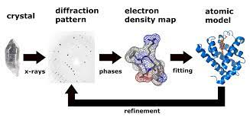

Fig. 1: Workflow for molecular structure analysis via X-ray Crystallography [[1]]

This method of analysis boasts of various advantages such as high precision, providing accurate atomic coordinates. It reveals the absolute configuration of chiral molecules and is suitable for a wide range of crystalline organic compounds. However, it requires the compound to form high-quality single crystals and the analysis can be run only for crystalline samples, which can be challenging for some organic compounds.

**1.1.2 Neutronography**

Neutronography, or neutron diffraction, is a method similar to X-ray crystallography but uses neutrons instead of X-rays to probe the atomic arrangement in a sample. Neutrons interact with the atomic nuclei, providing different structural information compared to X-rays.

Neutronography yields information about the positions of atomic nuclei, including hydrogen atoms, which are often challenging to locate using X-ray methods. It is especially useful for studying hydrogen bonding in organic compounds.

This technique provides accurate positions of hydrogen atoms, reveals information about the distribution of electrons and atomic nuclei and is suitable for organic compounds with hydrogen bonding and other light atoms.

However, there are few drawbacks for this method of analysis as neutron sources are less common and accessible than X-ray sources. Data collection can be time-consuming, and it requires samples to be prepared in a crystalline form.

**1.1.3 Infrared Spectroscopy**

Infrared (IR) spectroscopy is a non-destructive analytical technique that measures the absorption and transmission of infrared light by a sample. It is based on the principle that different chemical bonds and functional groups absorb infrared radiation at specific frequencies, allowing for the identification of these groups.

IR spectroscopy provides information about the functional groups and chemical bonds present in an organic compound. It can identify the presence of specific groups like carbonyl, hydroxyl, or amino groups and provide insights into the compound's molecular structure. Basic instrumentation (principle) of infrared spectroscopy is presented in Fig. 2.

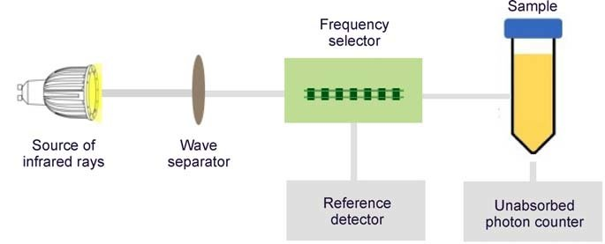

Fig. 2: Basic instrumentation (principle) of infrared spectroscopy [[2]]

This method of analysis is non-destructive and non-invasive, and provides rapid qualitative and semi-quantitative analysis. It is also suitable for a wide range of organic compounds in various states (solid, liquid, gas).

However, this technique is limited to the identification of functional groups and bonds, and not precise atomic coordinates. It cannot determine the three-dimensional arrangement of atoms, and may require additional techniques for comprehensive structural analysis.

**1.1.4** **Inelastic Neutron Scattering**

Inelastic Neutron Scattering (INS) is a sophisticated spectroscopic technique employed to explore the dynamic properties of materials. At its core, INS involves directing neutrons at a material and observing the resulting inelastic scattering as these neutrons interact with the vibrational and rotational motions of atoms within the sample.

INS is a powerful tool for unraveling the dynamic behavior of materials at the atomic and molecular levels. By analyzing the energy and momentum transfer of the scattered neutrons, researchers gain valuable insights into the vibrational and rotational modes of atoms. This detailed information provides a comprehensive understanding of phonon dispersion, lattice dynamics, and collective excitations in the material.

NERA spectrometer (Fig. 3) is designed to measure the spectra of elementary excitations in condensed matter that provide relevant data about interatomic interactions at the microscopic level that allows the most precise determination of the physical model of atomic/magnetic dynamics/structure of the substance under investigation, using advanced phenomenological and ab initio models, as well as quantum chemical calculations. In experiments on inelastic neutron scattering (INS), the change in energy and momentum transferred using a neutron during its interaction with the subject of research is measured.

INS offers several advantages, making it a cornerstone in material science research. It not only provides precise information about dynamic properties but also complements other structural methods like X-ray and neutron diffraction. The sensitivity of INS to light elements, including hydrogen, enhances its versatility, making it suitable for investigating a diverse range of materials, from crystalline structures to complex biological systems.

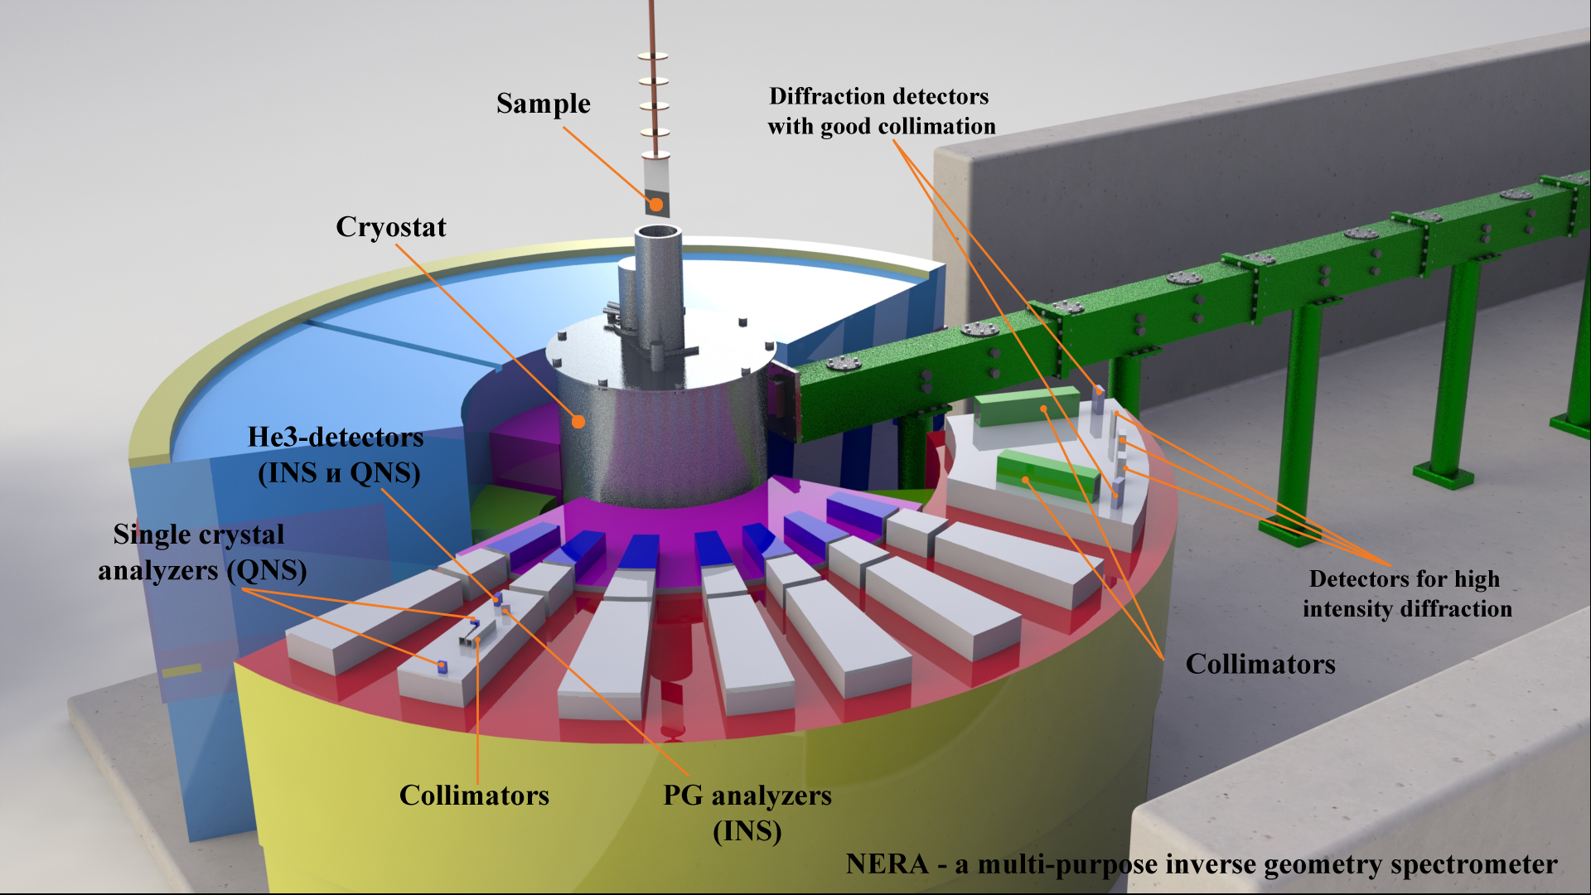

Fig. 3: Illustration for the working setup of NERA [[3]] (FLnP, JINR)

The implementation of INS requires specialized instrumentation and access to high-flux neutron sources. While the technique provides comprehensive insights into dynamic behavior, the complexity of data analysis often demands sophisticated modeling and simulations. Researchers need a robust infrastructure and expertise in neutron science to effectively utilize INS. A few areas of it’s eminent applications are:

* *Materials Science* – INS is crucial for studying the dynamics of crystalline materials, helping understand how atoms vibrate and rotate within a lattice.
* *Chemical Reactions* – INS provides insights into the dynamic aspects of chemical reactions, aiding in the understanding of reaction mechanisms.
* *Biology and Soft Matter* – In the study of biological macromolecules and soft matter, INS contributes to understanding molecular motions and flexibility.

The continued advancement of INS techniques, instrumentation, and data analysis methods holds promise for even deeper insights into material dynamics. Ongoing developments aim to enhance resolution, sensitivity, and the applicability of INS across various scientific domains.

**1.2. Quantum-chemical methods**

Quantum chemical methods are computational tools used to investigate the electronic structure and behavior of molecules based on principles of quantum mechanics. These methods solve the Schrödinger equation, providing insights into molecular properties, energetics, and reactivity. While ab initio methods offer high accuracy, they are computationally demanding. In contrast, semi-empirical methods strike a balance between accuracy and computational efficiency, making them suitable for the study of large and complex systems.

**1.2.1 Basics of Method development**

The development of semi-empirical methods [[4], [5]] like PM6, PM7, PM6-DH+, and PM6-DH2 is grounded in the parameterization of molecular properties based on experimental data. Parameters are adjusted to reproduce experimental observations, striking a balance between accuracy and computational efficiency. These methods incorporate quantum mechanical principles while simplifying calculations through empirical adjustments, enabling the study of complex molecular systems in a computationally tractable manner. The ongoing refinement of these methods reflects the continuous efforts to improve accuracy and extend their applicability to diverse classes of compounds, including bioactive molecules.

**1.2.2 Semi-Empirical methods**

* **PM6 (Parameterized Model 6):** PM6 is a semi-empirical method that considers parameters derived from experimental data to approximate electronic structure and predict molecular properties. Developed by James Stewart, it balances accuracy and computational cost, making it applicable to diverse molecular systems. PM6 is widely used in bioactive compound analysis due to its efficiency in handling large molecular structures. [[6]]
* **PM7:** An extension of PM6, PM7 incorporates additional parameters to enhance accuracy, especially in describing non-covalent interactions. Developed by James Stewart and collaborators, PM7 has proven particularly useful in the study of biomolecular systems, organic compounds, and bioactive molecules. Its improved accuracy makes it suitable for applications requiring a more detailed understanding of molecular interactions [[7]].
* **PM6-DH+:** PM6-DH+ introduces dispersion corrections (DH+) to PM6, enhancing its capability to model molecular interactions involving dispersion forces. The development, led by James Stewart, responds to the need for improved accuracy in describing non-bonded interactions, making it valuable for bioactive compounds with significant dispersion contributions [[8]].
* **PM6-DH2:** Building upon PM6-DH+, PM6-DH2 further refines dispersion corrections, providing a more accurate representation of molecular systems with substantial non-covalent interactions. Developed to address limitations in the description of dispersion forces, this method is particularly relevant for bioactive compounds where such interactions play a crucial role [[9], [10]].

**1.3. Generation of 3D structural models of chemical compounds**

The generation of three-dimensional (3D) structural models stands as a cornerstone in unraveling the intricate nature of chemical compounds. In the realm of molecular sciences, understanding a molecule's spatial arrangement is pivotal for predicting its properties, reactivity, and interactions. This process involves transforming flat, two-dimensional structural representations into dynamic 3D models that provide a holistic view of a molecule's conformation and geometry. Utilizing advanced computational tools, experimental data, and visualization techniques, researchers delve into the world of molecular architecture to decode the complexities that govern the behavior and functionality of chemical compounds.

For this project, ChemSketch [[11]] modeling software’s structure mode was used for generating the 2D models of the concerned organic compound, anthraquinone, for its structural analysis. Post which, 3D viewer was used and optimization of formed structures took place, that were offered by the ACD Labs in their software package.

**1.3.1 3D Modelling and Structural Information storage**

The generation and analysis of three-dimensional (3D) molecular structures are closely linked to the principles of storing structural information. While 3D structures offer a dynamic visual representation, linear notations and Z-matrix formats provide concise and standardized ways of storing and communicating complex structural information. Linear notations capture molecular structures in a linear sequence, aiding in data storage and transfer. On the other hand, Z-matrix format describes molecular geometry using internal coordinates, providing a systematic and computationally efficient approach for structural representation. Integrating these principles enhances our ability to store, communicate, and analyze intricate structural details, fostering a synergistic relationship between dynamic 3D models and structured storage formats.

**1.3.2 Linear Notations (1D level of structural information)**

Linear notations are a compact and human-readable way of representing the structure of a molecule or a chemical compound in a linear format. In this representation, atoms and their connections are listed in a single line or string of text, typically following specific rules or conventions. They provide a sequential list of atoms, their types (e.g., C for carbon, O for oxygen), and their connectivity (bonding relationships). They can include information about bond types, stereochemistry, and other structural details. These notations are generally compact and easy to read and write, well-suited for representing small to moderately sized molecules [[12], [13]]. However, these may not capture the three-dimensional (3D) spatial arrangement of atoms and are not ideal for complex, large, or highly flexible molecules. This notation type has limited ability to represent structural details beyond connectivity. Common examples include SMILES (Simplified Molecular Input Line Entry System) and InChI (IUPAC International Chemical Identifier). SMILES is a specification in the form of a [line notation](https://en.wikipedia.org/wiki/Line_notation) for describing the structure of [chemical species](https://en.wikipedia.org/wiki/Chemical_species) using short ASCII [strings](https://en.wikipedia.org/wiki/String_(computer_science)). SMILES strings can be imported by most molecule editors for conversion back into two-dimensional drawings or three-dimensional models of the molecules. The original SMILES specification was initiated in the 1980s [[14]]. It has since been modified and extended. InChI is a structure-based chemical identifier, originally developed by IUPAC. As a standard identifier for chemical databases, InChI is essential for enabling effective information management across chemistry [[15]].

**1.3.3 Internal Coordinates (Z-Matrix)**

Internal coordinates, often represented using the Z-matrix format, describe the positions of atoms in a molecule relative to one another. Instead of using Cartesian coordinates (x, y, z), internal coordinates use a set of angles, distances, and dihedral angles to define the positions of atoms. It is often hierarchical, starting from a reference atom (e.g., an origin) and specifying the positions of other atoms relative to it. It is well-suited for describing the 3D spatial arrangement of atoms in a molecule. This allows for the precise representation of molecular geometry and conformation and thus making It an essential tool for molecular simulations, energy calculations, and geometry optimizations [4, 12].

However, these are more complex and less human-readable compared to linear notations.

When compared to linear notations, these are less compact, which may make them less convenient for manual input. The Z-matrix representation can become unwieldy for large or highly flexible molecules.

1. **Calculation details**

**2.1. Molecular geometry generation**

For the work regarding this project, ChemSketch modelling software [11] was used to generate the 2D structure, optimize the 3D model and obtain the internal coordinates (z-matrix) of the anthraquinone molecule. The resulting output files were optimized by performing MOPAC Calculations (Semi empirical methods), details of which are mentioned in Table 1. The sequence of action for this step included:

* Designing 2D skeleton structure of the required molecule (anthraquinone).
* Generating 1D linear notation (for gathering information from databases).
* Building 3D models for visualization and conversion in the form of internal coordinates using the 3D Viewer feature of ChemSketch.

**2.2. Calculations with MOPAC2016**

All quantum chemical calculations were performed using the MOPAC2016 software package [[16]]. The following semi-empirical methods[4] were used in the work: PM6 (Parameterized Model 6) [6], PM7 [7], PM6-DH+[8], PM6-DH2 [9, 10]. At the first stage, the molecular geometry of anthraquinone was optimized. After this, vibrational frequencies and entropy were calculated. All calculations were performed with a final gradient norm of 0.03.

1. **Results and discussions**

**3.1. Anthraquinone: general information and application for Li-ion batteries**

Anthraquinone is a polycyclic aromatic hydrocarbon with a fused aromatic ring system. Its molecular structure consists of a central anthracene ring (three fused benzene rings) with two carbonyl groups (C=O) located at positions 9 and 10. This arrangement gives its characteristic planar and conjugated structure. Chemical structure of anthraquinone and corresponded 1D linear notations (SMILES and InChI) are presented in Fig. 4. 3D model of anthraquinone, generated within ChemSketch software, is presented in Fig. 5.

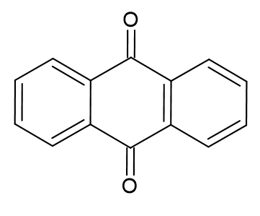

SMILES: O=C1c2ccccc2C(=O)c2ccccc21

InChI=1S/C14H8O2/c15-13-9-5-1-2-6-10(9)14(16)12-8-4-3-7-11(12)13/h1-8H

Fig. 4: 2D chemical skeleton and 1D linear notations of anthraquinone, generated within ChemSketch software

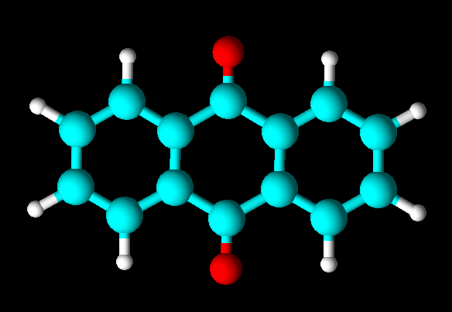

Fig. 5: 3D model of anthraquinone, generated within ChemSketch software

Anthraquinone, characterized by its fused aromatic ring structure, finds widespread applications across various industries. As a crucial chemical intermediate, it contributes to the vibrant colors in textiles, cosmetics, and consumer products through the production of dyes and pigments. In the paper industry, Anthraquinone serves as an additive in Kraft pulp processing, enhancing paper quality and strength. Its potential applications in advanced battery technologies highlight its role in energy storage systems [[17]]. Certain anthraquinone derivatives are explored for medicinal purposes, showing promise in traditional medicines for their anti-inflammatory and antioxidant effects. Additionally, anthraquinone plays a role in polymer synthesis for plastics, adhesives, and coatings, and is employed in the photography industry as a sensitizing agent for light-sensitive materials. This broad spectrum of applications underscores anthraquinone's versatility and significance in various industrial sectors.

One of the recent research works[[18]] explores the potential of Me4NAQ (tetramethyl tetraaza anthraquinone) and TCNAQ (tetracyano anthra quinodimethane) as cathodic materials for lithium ion batteries. Me4NAQ exhibits high charge/discharge voltage and exceptional cyclability, making it a promising candidate for enhancing battery performance. The study compares the properties of these derivatives with those of anthraquinone and reveals significant differences in their electron-accepting properties, reduction processes, and lithium-coordination abilities. Theoretical calculations and cyclic voltammetry demonstrate the distinct characteristics of Me4NAQ and TCNAQ, highlighting their potential for improving the performance of lithium ion batteries.

The 2nd discharge capacitiesof AQ, Me4NAQ, and TCNAQ were 259, 202, and 180 mAh/g, respectively, after subtracting the electric double-layer capacitance (EDLC) from the raw data [18]. Me4NAQ demonstrated a notably high charge/discharge voltage (2.9e2.5 V) and exceptional cyclability (>65% of the theoretical capacity after 30 cycles; no decrease after 15 cycles). The paper also includes figures depicting the molecular structures of Me4NAQ, TCNAQ, and AQ, providing visual representations of the investigated compounds. Overall, the findings underscore the promise of Me4NAQ and TCNAQ as high-performance cathodic materials for lithium ion batteries, offering valuable contributions to the development of organic cathodic materials for energy storage applications.

Another study investigated the impact of anthraquinone on the performance of polymer-based electrolytes [[19]] for lithium-ion batteries. Anthraquinone-containing polymers with varying molecular weights and structures were synthesized and evaluated. It was found that the solubility of these polymers decreases as the molecular weight increases. However, the electrode architecture was identified as a critical factor influencing the electrochemical performance. The high molecular weight linear polymers demonstrated reduced solubility and enhanced electrochemical performance, delivering high capacity and excellent cycling stability when the electrode preparation process was optimized. The incorporation of redox-active units, such as anthraquinone, into the polymer backbone was highlighted as an effective strategy to reduce solubility and improve the electrochemical performance of the polymer electrode materials.

Anthraquinone-based conjugated microporous polymers (ACMPs) [[20]]are revolutionizing energy storage with their remarkable properties. Boasting a specific surface area of up to 2200 m2/g, these polymers provide an expansive platform for redox reactions, enabling exceptional electrochemical performance. The ACMPs exhibit gravimetric capacities of around 100 mAh/g and retain an impressive 58% of their initial capacity over more than 80,000 cycles at 30 °C, showcasing their unprecedented long-term cyclability. What's more, the synthetic approach plays a pivotal role, as the combined miniemulsion polymerization plus solvothermal method yields nanostructured particles with enhanced specific surface area and new mesoporosity, underscoring the critical influence of synthetic conditions on the textural properties of ACMPs. With their compact electrode architecture and high volumetric capacity, these polymers are poised to drive the next generation of high-performance lithium-ion batteries, offering a tantalizing glimpse into the future of energy storage.

The use of anthraquinone as a covalently-linked pillar to construct a graphene framework [[21]] has significant implications for lithium-ion batteries. The anthraquinone-functionalized graphene framework offers enhanced specific capacity and improved lithium storage due to the additional Faradaic reaction in oxygen functional groups. This strategy makes the framework ideally suited for lithium storage, highlighting its potential as high-performance cathode materials. These findings underscore the crucial role of anthraquinone in enhancing the performance and capacity of lithium-ion batteries, positioning it as a key component in the development of advanced energy storage materials.

**3.2. Molecular geometry of anthraquinone**

Starting geometry of anthraquinone molecule was generated as a Z-matrix using ChemSketch and 3D Viewer tools. Semi-empirical methods implemented in MOPAC2016 software were used for the next geometry optimization. Fig. 6 presents 2D skeleton of anthraquinone molecule with atom numbering used for discussions. Equilibrium configuration of anthraquinone obtained in the approximation of the PM6 semi-empirical method is also presented in Fig. 6. The obtained equilibrium configuration of anthraquinone was used for further studies in the approximation of various semi-empirical methods. Selected parameters of the molecular geometry of anthraquinone, calculated in the approximation of the PM6, PM7, PM6-DH+, and PM6-DH2 methods, are listed in Table 1.

|  |  |
| --- | --- |
|  |  |

Fig. 6: 2D skeleton and equilibrium configuration of anthraquinone obtained in the approximation of the PM6 semi-empirical method

**Table 1**. Molecular geometry parameters of anthraquinone obtained in the approximation of the semi-empirical methods along with experimental data

|  |  |  |  |  |  |
| --- | --- | --- | --- | --- | --- |
| Parameter | PM6 | PM7 | PM6-DH+ | PM6-DH2 | Experiment [[22]] |
| C1-C2 (Å) | 1.406 | 1.398 | 1.388 | 1.386 | 1.37 |
| C9=O15 (Å) | 1.215 | 1.210 | 1.211 | 1.211 | 1.23 |
| C2-C4 (Å) | 1.396 | 1.393 | 1.385 | 1.385 | 1.39 |
| C8-C10-O16 (°) | 121.47 | 121.10 | 121.48 | 120.01 | 120.9 |
| C5-C3-C1 (°) | 120.12 | 119.88 | 330.03 | 120.01 | 120.4 |
| O16-C10-C2-C1 (°) | 180.1 | 178.0 | 180.3 | 179.9 | 179.9 |
| C5-C6-C4-C2 (°) | 0.0 | 0.0 | 0.0 | 0.1 | 0.4 |

Obtained molecular geometry parameters of anthraquinone were compared with corresponding experimental values. Experimental data for anthraquinone were taken from The Cambridge Crystallographic Data Centre [[23]], CSD Entry: ANTQUO . Experimental details are listed in ref. [22]. Based on the calculations and experimental data obtained, we can argue that **PM6-DH2**, being the advanced version of the PM6 model and known for its dispersion correction resulting in comparatively precise accuracy, is the best alternative to reproduce the molecular geometry parameters of anthraquinone.

**3.3. Thermodynamic parameters of anthraquinone**

On the base of equilibrium molecular geometries of anthraquinone the following thermodynamic parameters were calculated: standard enthalpy of formation (*ΔfH0*, kJ·mol-1), standard entropy of formation (*fS0*, kJ·mol-1), and heat capacity (Cp, J·mol-1·K-1) at constant pressure. All calculated values are listed in Table 2 along with experimental ones. Experimental data for anthraquinone were taken from NIST Chemistry WebBook [[24], [25]].

**Table 2**. Thermodynamicparameters of anthraquinone obtained in the approximation of the semi-empirical methods along with experimental data

|  |  |  |  |  |  |
| --- | --- | --- | --- | --- | --- |
| Parameter | PM6 | PM7 | PM6-DH+ | PM6-DH2 | Experimental |
| *ΔfH0*, kJ·mol-1 | -45.68 | -55.22 | -62.60 | -62.60 | -75.7 ± 2.9 [24, [26]] |
| *fS0*, J·mol-1·K-1 | 440.86 | 438.64 | 441.64 | 441.20 | - |
| Cp, J·mol-1·K-1 | 203.95 | 198.47 | 203.95 | 203.94 | 197.78 [25, [27]] |

Based on the comparative analysis of calculations and the data from experimental results, PM7 provided the closest result for heat capacity (Cp) at constant pressure, whereas **PM6-DH2** emerged as the best choice for standard enthalpy of formation of gas. Overall, **PM7**, being the advanced version parameter for PM6, (along with PM6-DH+/DH2) provides more accurate results when computational efficiency is sufficient for carrying out the calculations.

**3.4. IR-spectrum of anthraquinone: main features**

In Table 3 the selected experimental data and results from our calculation of frequencies, are presented. For comparative analysis the experimental IR spectrum of anthraquinone in the gas phase was used [[28]]. For a number of the vibrations, we can note a certain characteristic features. One of the intense absorption bands, observed in the spectrum at 1690 cm-1, corresponds to the thoroughly studied and interpreted stretching vibration of the carbonyl group (ν C=O). From the calculations two value were obtained for symmetrical and antisymmetrical vibrations of both carbonyl groups. The next intense band is at 1593 cm-1. The values of the frequency and intensity of this vibration are determined by parameters of different structural groups. The frequency pertains to stretching vibrations of CC bonds of the side fragments. In the experimental spectrum on can see two very intense absorption bands in the 1400-1200 cm-1 frequency region. They are determined by bendings of C-C and C-H bonds. Out-of-plain bendings of C-C and C-H bonds are characterized by 806 cm-1 and 698 cm-1 bands. The medium-intensity absorption band at 939 cm-1 pertains to a stretching-bending vibration with equal participation of stretches of the CCp bonds of the side fragments and bends of the CCO angles.

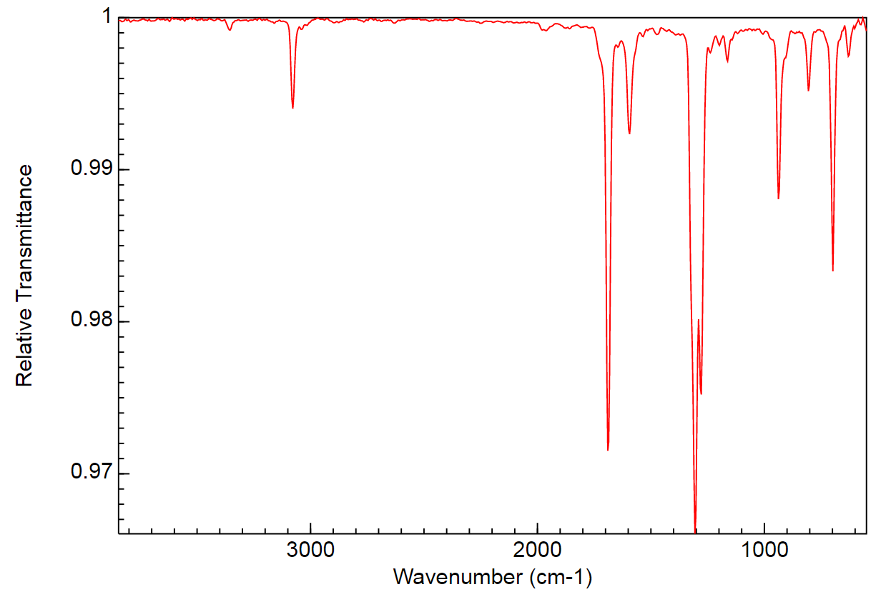

Fig. 3. Experimental IR-spectrum of anthraquinone (condensed phase) as reported in NIST database[28]

**Table 3**. Assignment of selected IR bands (cm−1) for anthraquinone: experimental and calculated data

|  |  |  |  |  |  |
| --- | --- | --- | --- | --- | --- |
| Type of vibrations | PM6 | PM7 | PM6-DH+ | PM6-DH2 | Experimental [28] |
| νsym C-H in ϕ | 2757 | 2763 | 2757 | 2746 | 2964 |
| ν C=O | 1777 | 1825 | 1777 | 1782 | 1690 |
| 1769 | 1827 | 1769 | 1768 |
| ν C-C in ϕ | 1650 | 1716 | 1650 | 1649 | 1593 |
| ν C-C in ϕ | 1629 | 1695 | 1630 | 1632 |
| δ C-C in ϕ | 1311 | 1368 | 1311 | 1311 | 1302 |
| δ C-H in ϕ | 1267 | 1334 | 1268 | 1268 | 1279 |
| ν C-C in ϕ, δ C-C-O | 1035 | 1061 | 1037 | 1036 | 939 |
| δ C-H in ϕ (out-of-plain) | 811 | 824 | 811 | 811 | 806 |
| δ C-C in ϕ (out-of-plain) | 685 | 705 | 685 | 685 | 698 |

Notes: ϕ – benzene ring, ν – stretching modes, δ – bending modes

The vibrational and intensity frequencies are crucial for understanding the IR spectrum of anthraquinone. Theoretical calculations enable the construction of a complete spectral curve, essential for correct analysis and interpretation of experimental spectra. The agreement between theoretical and experimental spectra, along with characteristic vibrational frequencies and intensities, provides important insights into the molecule's properties.

Based on the calculations and data from Table 3, we can argue that **PM6** (Parametric Model) and it’s advanced versions (PM6-DH+ and PM6-DH2) are a better choice to reproduce the theoretical data due to their comparatively close resemblance and converging results for the given band spectrum.

**Conclusions**

This project systematically explored anthraquinone's properties, beginning with molecular geometry optimization using ChemSketch and progressing to gas-phase thermochemistry analysis with MOPAC2016, employing semi-empirical methods (PM6, PM7, PM6-DH+, PM6-DH2). The assignment of IR bands complemented these analyses, bridging theoretical and experimental insights. The numeric results and comparative analysis provided insights about the accuracy and efficiencies of different quantum chemical models for different as well as varied scientific use cases.

For the anthraquinone molecule, optimization of the molecular geometry and calculation of thermodynamic parameters and vibrational frequencies were carried out in the approximation of various semi-empirical methods (PM6, PM7, PM6-DH+, PM6-DH2). As a result of a comparative analysis of experimental data and molecular modeling results, the PM6-DH2 method can be proposed as the most promising for further use from those implemented in MOPAC2016 software.

A thorough literature review contextualized our findings, ensuring alignment with established knowledge. This project provided a platform for the management and analysis of quantum chemical data and this cohesive approach not only deepened our understanding of anthraquinone but also exemplified the symbiosis between theory and experiment in molecular sciences.

**Acknowledgments**

I extend my sincere gratitude to my project supervisor, **Dr Elena V. Raksha**, for their invaluable guidance and unwavering support throughout this research endeavor. Their expertise and insightful feedback have been instrumental in shaping the trajectory of this project. I would like to thank the **Frank Laboratory of Neutron Physics**, for providing me this opportunity to work on this project. I would also like to acknowledge the INTErnational REmote Student Training **(INTEREST)** team of the **Joint Institute for Nuclear Research (JINR)**, Dubna for providing the necessary resources and facilitating an enriching research environment. Additionally, my appreciation goes to my faculty mentor(s) at the Department of Applied Chemistry, **Delhi Technological University**, New Delhi for their assistance and collaboration. Last but not the least, I would like to thank my parents, friends and batchmates for their unwavering support throughout the duration of this research project. This project has truly benefited from the collective efforts and support of those involved.

**References**

1. . The public domain image Myoglobindiffraction.png <https://commons.wikimedia.org/w/index.-php?curid=1248574> (retrieved December 13, 2023)
2. . Naveed, M., Raees, M., Liaqat, I., & Kashif, M. (2018). Clastogenic ROS and biophotonics in precancerous diagnosis. Frontiers in Biology, 13(2), P. 103–122.
3. . <https://flnp.jinr.int/en-us/main/facilities/materials/nera-2> (retrieved December 13, 2023)
4. . Alan Hinchliffe. Molecular Modelling for Beginners, 2nd Edition, 2003, John Wiley & Sons Ltd, ISBN: 978-0-470-51314-9
5. . <https://gaussian.com/semiempirical/> (retrieved December 13, 2023)
6. . Stewart, J. J. P., Optimization of Parameters for Semiempirical Methods V: Modification of NDDO Approximations and Application to 70 Elements (2007). J. Mol. Modeling, 13, P. 1173-1213.
7. . Stewart J. J. P., Optimization of parameters for semiempirical methods VI: more modifications to the NDDO approximations and re-optimization of parameters (2013). J. Mol. Modeling, 19, P. 1-32.
8. . Korth, M. Third-Generation Hydrogen-Bonding Corrections for Semiempirical QM Methods and Force Fields (2010). J. Chem. Theory Comput. 6 (12), P. 3808–3816.
9. . Korth, M., Pitonák, M., Rezác, J. and Hobza, P. A Transferable H-bonding Correction For Semiempirical Quantum-Chemical Methods (2010). J. Chem. Theory Comp., *6,* P*.* 344–352
10. . Rezác, J., Fanfrlik, J., Salahub D., and Hobza, P. Semiempirical Quantum Chemical PM6 Method Augmented by Dispersion and H-Bonding Correction Terms Reliably Describes Various Types of Noncovalent Complexes (2009). J. Chem. Theory Comp, 5, P. 1749-1760.
11. . <https://www.acdlabs.com/resources/free-chemistry-software-apps/chemsketch-freeware/> (retrieved December 13, 2023)
12. . Höltje H-D., Sippl W., Rognan D., Folkers G. Molecular Modeling: Basic Principles and Applications, 2008, Wiley-VCH, ISBN: 978-3527315680
13. . David, L., Thakkar, A., Mercado, R., & Engkvist, O. Molecular representations in AI-driven drug discovery: a review and practical guide. (2020). Journal of Cheminformatics, 1*2*(1), 56.
14. . Weininger, D. SMILES, a chemical language and information system. 1. Introduction to methodology and encoding rules (1988). J. Chem. Inf. Comput. Sci.  28(1), 3P. 1–36.
15. . Leigh, J. InChIs and Registry Numbers. Chemistry International – Newsmagazine for IUPAC, (2012). 34(6), P. 23-23.
16. . MOPAC2016, James J. P. Stewart, Stewart Computational Chemistry, Colorado Springs, CO, USA, HTTP://OpenMOPAC.net (2016). (retrieved December 13, 2023)
17. . Anthraquinone. PubChem Identifier: CID 6780. [https://pubchem.ncbi.nlm.nih.gov/  
    compound/6780](https://pubchem.ncbi.nlm.nih.gov/compound/6780) (retrieved December 13, 2023)
18. . Takeda, T., Taniki, R., Masuda, A., Honma, I., & Akutagawa, T. (2016). Electron-deficient anthraquinone derivatives as cathodic material for lithium ion batteries. Journal of Power Sources, 328, P. 228–234.
19. . Yang, J., Shi, Y., Sun, P., Xiong, P., & Xu, Y. (2019). Optimization of Molecular Structure and Electrode Architecture of Anthraquinone Containing Polymer Cathode for High Performance Lithium-Ion Batteries. ACS Applied Materials & Interfaces. ACS Appl. Mater. Interfaces, 11(45), P. 42305–42312
20. . Molina, A., Patil, N., Ventosa, E., Liras, M., Palma, J., & Marcilla, R. New Anthraquinone-Based Conjugated Microporous Polymer Cathode with Ultrahigh Specific Surface Area for High-Performance Lithium-Ion Batteries. (2019). Advanced Functional Materials, 1908074.
21. . Qin, Y., Li, J., Jin, X., Jiao, S., Chen, Y., Cai, W., & Cao, R. (2020). Anthraquinone-functionalized graphene framework for supercapacitors and lithium batteries. Ceramics International, 46(10), P. 15379-15384.
22. . Murty, B.V.R. Zeitschrift fur Kristallographie, Kristallgeomie, Krystallphysik, Kristallchemie, 1960, 113, 445.
23. . <https://www.ccdc.cam.ac.uk/structures/Search>? Compound=anthraquinone&Database ToSearch=Published (retrieved December 13, 2023)
24. . Burgess, D.R., " Thermochemical Data" in NIST Chemistry WebBook, NIST Standard Reference Database Number 69, Eds. P.J. Linstrom and W.G. Mallard, National Institute of Standards and Technology, Gaithersburg MD, 20899, <https://doi.org/10.18434/T4D303>, (retrieved December 14, 2023).
25. . Domalski, E.S., Hearing, E.D. "Condensed Phase Heat Capacity Data" in NIST Chemistry WebBook, NIST Standard Reference Database Number 69, Eds. P.J. Linstrom and W.G. Mallard, National Institute of Standards and Technology, Gaithersburg MD, 20899, <https://doi.org/10.18434/T4D303>, (retrieved December 14, 2023).
26. . Ribeiro Da Silva, M.A.V.; Ribeiro Da Silva, D.M.C.; Teixeira, J.A.S., Enthalpies of combustion of 1,4-naphthoquinone, 9,10-anthraquinone, 9,10-phenanthraquinone, 1,4,9,10-anthradiquinone, 5,8-dihydroxy-1,4-naphthoquinone, and 1,4-dihydroxy-9,10-anthr-quinone, (1989), J. Chem. Thermodyn., 21, P. 265-274.
27. . Singh, S.N., Thermodynamic properties of some condensed ring quinones, (1969). **Indian J. Pure** Appl. Phys., 7, P. 52-53.
28. . Wallace, W.E. Infrared Spectra by NIST Mass Spectrometry Data Center, in**NIST Chemistry WebBook, NIST Standard Reference Database Number 69,** Eds. P.J. Linstrom and W.G. Mallard, National Institute of Standards and Technology, Gaithersburg MD, 20899, <https://doi.org/10.18434/T4D303>, (retrieved December 13, 2023)