

JOINT INSTITUTE FOR NUCLEAR RESEARCH

Dzhelepov Laboratory of Nuclear Problems

**FINAL REPORT ON THE**

**INTEREST PROGRAMME**

*“Application of semiconductor pixel detectors from the Timepix family in nuclear medicine tasks (SPECT, CT).”*

**Supervisor:**

**Dr. Vladislav Rozhkov**

**Students:**

**Gurleen Kaur**

ICT-IOCB, India

**Polina Krivovyazenko**

National Research Nuclear University MEPhI. Russia

**Participation period:**

November 05 – December 14, Wave 11

Dubna, 2024

**Abstract**

SPECT and CT are two of the most important imaging modalities applied in nuclear medicine in the diagnosis of conditions, planning of treatment, and follow-up of results. The aim of this work is to produce quality imaging utilizing high sensitivity and energy resolution using a semiconductor pixel detector known as Timepix. More advance reconstruction techniques, such as MLEM, were applied with higher resolution of the images in order to remove more artefacts for more biologically representative ones.

This project shows the ability of Timepix detectors to generate high-resolution artifact-free images by using customized experimental setups and data processing techniques. Advanced detectors coupled with iterative algorithms such as MLEM are capable of revolutionizing nuclear medicine by increasing the diagnostic accuracy and improved clinical imaging outcomes.

**Introduction**

Medical imaging technologies have changed beyond recognition, with SPECT and CT at the forefront of modern health care: to not only visualize anatomy with unprecedented precision but to gain invaluable insights into functional processes that enable early detection, effective treatment planning, and robust monitoring of disease progression. It is thus an area that calls for innovation in imaging procedures and equipment, even with the widespread use, in addition to the limitations like artifacts or noise interference in images with low resolution.

One of the promising ways for medical imaging tasks is semiconductor pixel detectors, particularly those from the family of Timepix. These detectors are sensitive, provide good energy resolution, and offer great operational flexibility. This makes them perfect for raising the accuracy and reliability of imaging results. The potential of these detectors to recognize low-energy photons and separate different kinds of radiation offers them a tremendous advantage over ordinary imaging technologies. These features have made Timepix detectors invaluable in medical imaging as well as in fields like environmental monitoring and nuclear research.

Computed tomography, which reconstructs detailed cross-sectional images using X-rays, is one of the cornerstones of diagnostic radiology. Traditional reconstruction techniques, such as filtered back projection, are computationally fast but vulnerable to artifacts and generally lead to a decrease in diagnostic accuracy. Novel iterative reconstruction methods and emerging concepts of deep learning do not fall into this pitfall. SPECT imaging, which relies on the emission of gamma rays by radiopharmaceuticals to measure organ function and detect abnormalities, similarly suffers from problems in obtaining high-resolution, artifact-free images. This project has been developed to use Timepix semiconductor detectors for overcoming the drawbacks involved in SPECT and CT imaging[1]. Advanced reconstruction methods incorporated are MLEM, along with improving image quality and removing artifacts, thereby enhancing diagnostic dependability. The research will check the efficacy of these new detectors in revolutionizing nuclear medicine and advancing patient care through both practical experiments and analytical review.

**Fundamentals of Radiation Interaction with Matter**

Radiation interaction with matter is the cornerstone of understanding and optimizing radiation detection and imaging technologies. These interactions determine how photons behave as they traverse through various materials, influencing their energy, direction, and intensity. In the context of medical imaging and nuclear medicine, three principal interaction mechanisms stand out: the photoelectric effect, Compton scattering, and pair production. These processes, coupled with concepts like linear and mass attenuation coefficients, provide the theoretical framework for radiation detection and image reconstruction.

**Key Processes:**

* **Photoelectric Effect:**

The photoelectric effect occurs when a photon interacts with an atom, transferring its energy to eject an electron from one of the atom's inner shells. The entire photon energy is absorbed, with the kinetic energy of the ejected electron being the photon's energy minus the electron's binding energy. This interaction dominates at lower photon energies and is more prevalent in materials with high atomic numbers (ZZZ). The precise energy absorption provided by this process is critical for high-resolution imaging in systems like Single Photon Emission Computed Tomography (SPECT). Secondary emissions, such as X-ray fluorescence or Auger electrons, may result, further contributing to the interaction dynamics.

* **Compton Scattering:**  
  Compton scattering involves a photon colliding with a loosely bound or free electron, transferring a portion of its energy to the electron and scattering at a different angle. This mechanism dominates at intermediate photon energies and is relatively independent of the material's atomic number. While it can introduce noise in imaging systems, advanced algorithms, like those implemented in Timepix detectors, can correct for this, leveraging the scattered photon data for clearer images.
* **Pair Production:**  
  At photon energies exceeding 1.022 MeV, pair production becomes significant. Here, the photon interacts with the electromagnetic field of an atomic nucleus, converting its energy into an electron-positron pair. The remaining energy, after accounting for the rest mass of the particles, is shared as their kinetic energy. Though rare in typical medical imaging, pair production is crucial for applications in high-energy physics and advanced imaging techniques like positron emission tomography (PET).

**Applications and Importance:**

Understanding these interactions enables the development of optimized detectors, like those in the Timepix family, which utilize their high sensitivity and energy resolution to capitalize on these processes. For instance:

* **Photoelectric effect** ensures accurate photon energy measurements in SPECT imaging.
* **Compton scattering** data is corrected to improve image quality in CT reconstructions.
* **Pair production** forms the basis for PET imaging, leveraging annihilation photons for high-resolution imaging.

The attenuation coefficients further guide the selection of materials for shielding in medical radiology and nuclear facilities, ensuring safety and efficiency. This knowledge bridges the gap between theoretical physics and practical applications in medical imaging, driving advancements in diagnostic precision and therapeutic outcomes[2].

**Timepix Detectors: Features and Applications**

Timepix detectors are advanced semiconductor devices designed for precise particle detection and imaging applications. These detectors employ a planar pixelated semiconductor sensor that is bump-bonded to a readout chip, enabling each pixel to function as an independent sensor. With a resolution of 256 × 256 pixels and a pixel pitch of 55 µm, Timepix detectors provide detailed spatial information.

Timepix operates in multiple modes, including Counting (registering particle hits), Time-over-Threshold (TOT, measuring particle energy), and Time-of-Arrival (TOA, measuring interaction timing). These versatile operational modes make them suitable for a range of applications, from radiation dose monitoring to high-resolution imaging in CT and SPECT. The detectors' ability to operate with minimal thresholds (3.5 keV) and their dynamic range make them an excellent choice for precision medical imaging and other scientific endeavors.

**CT and SPECT Imaging Methodologies**

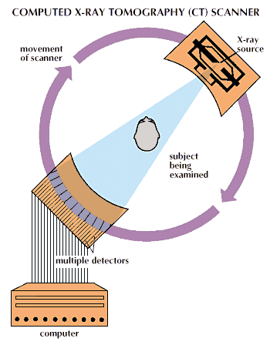**Computed Tomography (CT)** is a vital imaging modality that uses X-rays to capture cross-sectional images of the body's internal structures. During a CT scan, the system acquires multiple projections of the target region from various angles as the X-ray source rotates around the patient. These projections are processed by specialized algorithms to construct detailed three-dimensional images, enabling clinicians to analyze tissues, bones, and organs with remarkable clarity. CT imaging is widely utilized for diagnosing conditions like fractures, tumors, and vascular abnormalities and is indispensable in treatment planning and disease monitoring[3].

**Figure 1:** CT Scanner Schematic[1]

**Single Photon Emission Computed Tomography (SPECT)** is a nuclear imaging technique that employs radiopharmaceuticals to visualize physiological processes in the body. During a SPECT scan, gamma cameras rotate around the patient, capturing the gamma rays emitted as the radiopharmaceutical decays. These emissions are used to construct detailed three-dimensional images, providing functional insights into organs and tissues. Unlike CT, which focuses on structural details, SPECT highlights metabolic activity and blood flow, making it particularly valuable for diagnosing cardiovascular conditions, cancers, and neurological disorders[4].

A critical component of SPECT imaging is the collimator, which focuses gamma rays to ensure that only emissions from specific directions reach the detector. This precision enhances spatial resolution while reducing scatter interference. Reconstruction techniques like MLEM are widely used in SPECT to achieve high-quality images by iteratively refining the estimates of radiopharmaceutical distribution[5].

Advancements in SPECT methodologies, combined with the integration of semiconductor detectors, have further improved diagnostic accuracy. Semiconductor detectors, such as those from the Timepix family, offer enhanced sensitivity and resolution, enabling clearer visualization of radiopharmaceutical uptake. These improvements have significantly expanded the potential of SPECT imaging in both clinical and research settings.

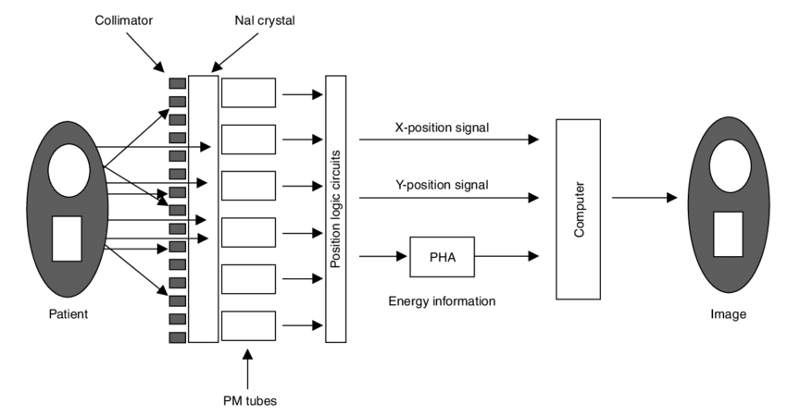

**Figure 2:** Basic components of a single photon imaging device (Anger camera) used for planar or single photon emission computed tomography (SPECT) imaging. PHA = pulse height analyser; PM = photomultiplier[10].

**Integration of Semiconductor Detectors in CT and SPECT**

The integration of Timepix semiconductor detectors into CT and SPECT imaging systems has proven transformative. These detectors provide high sensitivity and energy resolution, enabling precise detection of radiation and the differentiation of low-energy photons. Their ability to minimize noise and improve image fidelity makes them ideal for medical imaging applications[6].

In CT imaging, Timepix detectors enhance the accuracy of reconstruction algorithms, reducing artifacts and improving spatial resolution. For SPECT, they improve the detection of gamma rays and enhance the visualization of radiopharmaceutical distributions within tissues. The combination of advanced reconstruction techniques and these cutting-edge detectors opens new possibilities for more reliable and accurate diagnostics[7].

**MLEM Reconstruction Technique**

Maximum Likelihood Expectation Maximization (MLEM) is a powerful iterative reconstruction algorithm widely used in CT and SPECT imaging. The algorithm refines the estimated image by considering the statistical properties of photon interactions and the physical model of the imaging system. This iterative process allows for better artifact reduction and enhanced resolution compared to traditional reconstruction methods.

MLEM is particularly effective in situations where noise levels are high or where accurate representation of low-contrast regions is critical. Its implementation, combined with the precision of Timepix detectors, significantly improves diagnostic accuracy and reduces the likelihood of false negatives[8].

In addition to its accuracy, MLEM is highly adaptable, allowing customization of iterations to balance computational efficiency and image quality. This flexibility makes it ideal for both clinical and research applications, where imaging requirements can vary significantly. It also ensures consistent performance across diverse imaging scenarios, from detecting small abnormalities to visualizing complex anatomical structures.

When integrated with advanced detector systems like Timepix, MLEM demonstrates remarkable synergy. The precise spatial and energy data provided by Timepix enhances the algorithm's ability to reconstruct images with minimal artifacts. Together, they enable clinicians and researchers to achieve unprecedented levels of detail, pushing the boundaries of what is possible in medical imaging[9].

**Results**

**Overview of Projections**

The quality of reconstructed CT images is directly influenced by the number of projections used during acquisition. Projections represent the radiographic views captured at various angles, providing data necessary for reconstructing the image. With 200 projections, the reconstructions displayed essential structural information but suffered from noise, blurred edges, and artifacts due to insufficient angular coverage. In contrast, increasing the projections to 2000 improved the quality significantly, reducing artifacts and providing finer details with smoother transitions. The additional projections captured more angular perspectives of the object, contributing to higher fidelity and better resolution.

**Sinograms**

Sinograms are a key representation of raw projection data collected at various angles during a CT scan, serving as the foundation for image reconstruction. Each row in a sinogram corresponds to a projection at a specific angle, and columns represent the intensity of rays passing through the object at different radial distances. The quality and density of sinograms directly influence the accuracy of the reconstructed image.

Using the provided code, sinograms were generated by applying the Radon Transform to input images, capturing projections across evenly spaced angles from 0° to 180°. Two sinograms were analyzed:

* **200 Projections**: Sparse angular sampling resulted in gaps and discontinuities, limiting detail and resolution in reconstructed images.
* **2000 Projections**: Dense angular coverage provided smoother and more continuous intensity data, capturing finer structural details and reducing artifacts.

**Backprojection**

Backprojection is the most straightforward reconstruction method, where each projection is "smeared" back along its corresponding angle to form the image. The reconstructed images from 200 projections showed noticeable streak artifacts and lacked detail. The gray-value plots indicated significant fluctuations, highlighting the method’s susceptibility to noise. Increasing the projections to 2000 reduced artifacts and improved the clarity, but the method still struggled with preserving edge details and resolving fine structures. While backprojection is simple and effective for basic reconstructions, its limitations in handling noise and artifacts make it less suitable for high-quality imaging.

**Filtered Backprojection (FBP)**

Filtered Backprojection improves upon backprojection by applying frequency-domain filters, such as the Hann or Ramp filters, to suppress noise and sharpen edges. For 200 projections, the reconstructed images showed a marked reduction in artifacts compared to unfiltered backprojection. The gray-value plots were smoother, with better edge definition and less fluctuation. At 2000 projections, FBP produced highly refined images with well-preserved edges and uniform intensity distributions. The choice of filters also impacted the results: while the Ramp filter excelled at preserving sharp edges, it introduced slight noise, whereas the Hann filter provided a smoother but slightly blurred image. FBP strikes a balance between computational efficiency and image quality, making it one of the most versatile methods for CT reconstruction.

**Fast Fourier Transform (FFT)**

The FFT method reconstructs images by decomposing spatial information into frequency components, which can then be filtered and recombined to form the final image. With 200 projections, FFT-based reconstructions were computationally efficient but exhibited blurring in high-frequency regions due to limited angular data. The gray-value plots showed moderate smoothness but lacked sharp transitions, indicating a loss of edge details. At 2000 projections, the additional frequency data resulted in better resolution, with clearer edges and reduced noise. However, FFT remained sensitive to noise in high-frequency regions, necessitating careful filtering to achieve optimal results. This method is ideal for applications requiring rapid reconstruction but less sensitive to fine structural details.

**Maximum Likelihood Expectation Maximization (MLEM)**

MLEM employs an iterative approach to refine the reconstructed image by maximizing the statistical likelihood of the observed data. With 200 projections, MLEM produced relatively accurate images, outperforming other methods in preserving low-contrast regions and subtle features. The gray-value plots demonstrated minimal noise and smoother transitions, even with fewer projections. At 2000 projections, MLEM excelled in capturing fine details and providing high-resolution images with minimal artifacts. The iterative nature of the method allowed it to achieve superior detail preservation, particularly in regions with subtle intensity variations. Despite its computational cost, MLEM proved to be the most robust method for high-quality reconstructions.

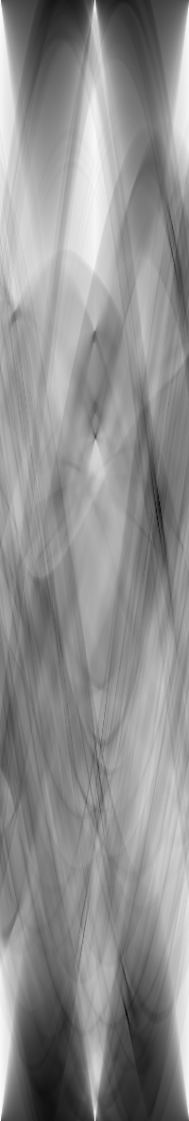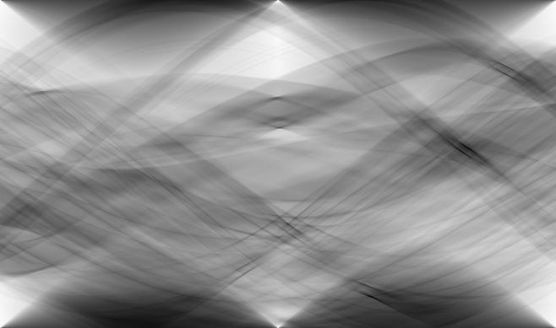

**Sinogram_200**

**Sinogram_2000**

**Figure 3:** The sinograms illustrate the projection data captured at various angles during the CT scan. The 200-projection sinogram demonstrates sparse angular coverage with visible gaps, leading to reduced reconstruction accuracy. In contrast, the 2000-projection sinogram shows dense and continuous data, ensuring smoother and more detailed reconstructions.



**Back_Projection_200**

**FFT_2000**

**FFT_200**

**FBP_200**

**FBP_2000**

**Back_Projection_2000**

**Original_16bit**



**MLEM_200**

**MLEM_2000**

**Figure 4:** The reconstructed images showcase results from different reconstruction methods and projection densities. Backprojection exhibits significant noise and artifacts with 200 projections, but clarity improves with 2000 projections. Filtered Backprojection and FFT reconstructions demonstrate enhanced sharpness and reduced noise as projection density increases. MLEM consistently delivers the highest-quality images, with excellent detail preservation and minimal artifacts, even at lower projection counts.

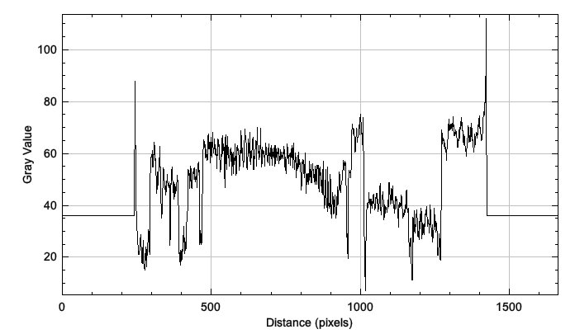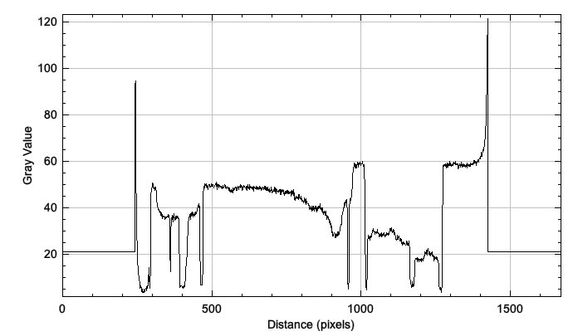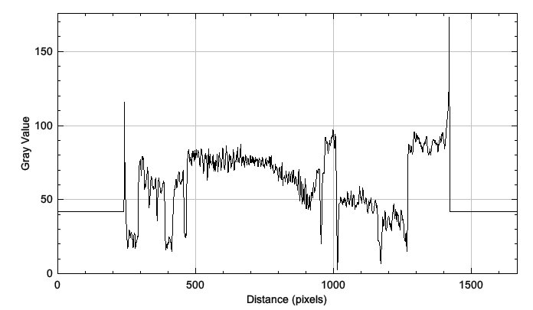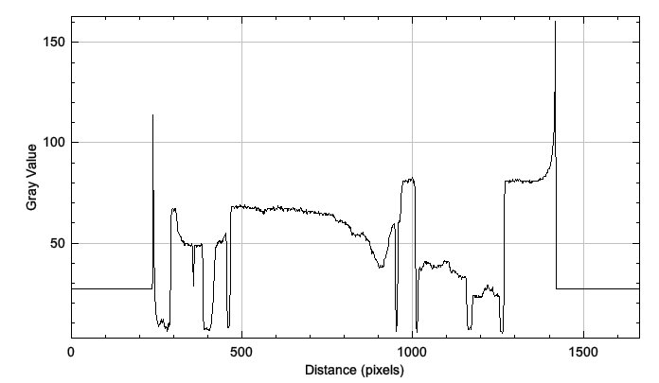

**Back_Projection_200**

**Back_Projection_2000**

**FBP_200**

**FBP_2000**

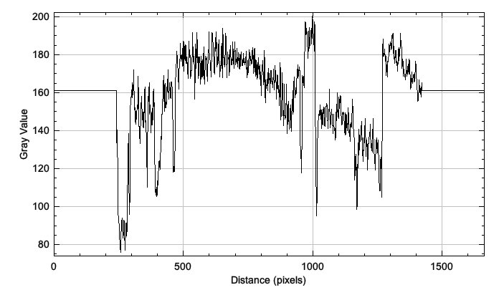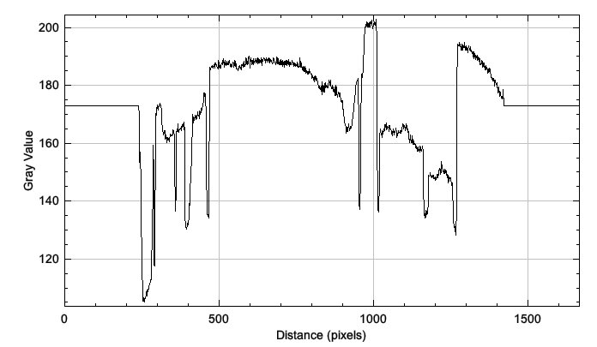

**FFT_200**

**FFT_2000**

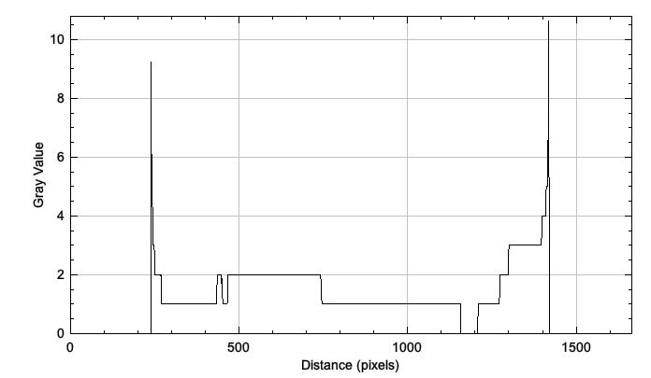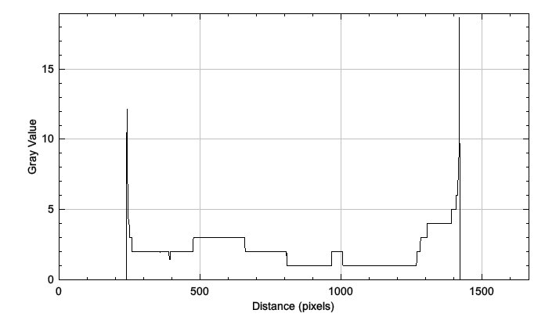

**MLEM_200**

**MLEM_2000**

**Figure 5:** The gray-value plots evaluate intensity transitions across the reconstructed images. Sparse projections (200) show noisy, fluctuating profiles, while dense projections (2000) provide smoother transitions and sharper edges. Among the methods, MLEM and Filtered Backprojection exhibit the most refined profiles, with well-preserved details and minimal noise.

**Comparison of Results**

The number of projections had a profound impact on all reconstruction methods:

* At 200 projections, all methods struggled with noise and artifacts, with MLEM and FBP providing relatively better results.
* At 2000 projections, FBP and MLEM demonstrated significant improvements, producing high-quality images with minimal artifacts and smoother gray-value transitions.
* Backprojection, even with 2000 projections, retained artifacts and lacked the refinement offered by other methods.
* FFT showed consistent performance with moderate computational efficiency but required careful noise handling for high-detail images.

**Conclusion**

This project highlights the critical role of advanced imaging and reconstruction techniques in enhancing Computed Tomography (CT) and Single Photon Emission Computed Tomography (SPECT). By exploring various reconstruction methods—Backprojection, Filtered Backprojection (FBP), Fast Fourier Transform (FFT), and Maximum Likelihood Expectation Maximization (MLEM)—and evaluating their performance with different projection counts, we demonstrated how computational advancements can significantly improve image quality. The experiments revealed that increasing the number of projections from 200 to 2000 reduced noise and artifacts while capturing finer details, emphasizing the importance of sufficient angular data for accurate reconstructions.

Among the methods analyzed, FBP and MLEM proved to be the most effective for achieving high-quality imaging. FBP offered a balance between efficiency and image clarity, especially with appropriate filtering, while MLEM excelled in preserving subtle intensity variations and fine details, albeit at a higher computational cost. FFT provided an efficient alternative but required careful noise management, and Backprojection, though simple, was limited by artifacts and noise. The gray-value analysis further validated the effectiveness of these methods, with FBP and MLEM producing smoother intensity transitions and sharper edges compared to the others.

The findings of this project underscore the potential of integrating advanced reconstruction techniques with semiconductor detectors, such as those from the Timepix family, to revolutionize medical imaging. The superior sensitivity and resolution of these detectors, combined with optimized reconstruction methods, pave the way for more accurate diagnostics and treatment planning. Continued research in this field will be vital to overcoming computational challenges and maximizing the benefits of these technologies in clinical applications, ultimately improving patient care and outcomes.

**References**

[1] V. Rozhkov, M. Elsabagh, and S. Kathirvel, “FINAL REPORT ON THE INTEREST PROGRAMME Application of semiconductor pixel detectors from the Timepix family in nuclear medicine tasks (SPECT, CT).”

[2] S. Mobilio, “Introduction to Matter Radiation Interaction,” in *Synchrotron Radiation: Basics, Methods and Applications*, S. Mobilio, F. Boscherini, and C. Meneghini, Eds., Berlin, Heidelberg: Springer Berlin Heidelberg, 2015, pp. 107–143. doi: 10.1007/978-3-642-55315-8_4.

[3] J. Greffier, J. Frandon, A. Larbi, J. P. Beregi, and F. Pereira, “CT iterative reconstruction algorithms: a task-based image quality assessment,” *Eur Radiol*, vol. 30, no. 1, pp. 487–500, Jan. 2020, doi: 10.1007/s00330-019-06359-6.

[4] R. Garnett, “A comprehensive review of dual-energy and multi-spectral computed tomography,” *Clin Imaging*, vol. 67, pp. 160–169, Nov. 2020, doi: 10.1016/j.clinimag.2020.07.030.

[5] S. Horbelt, M. Liebling, and M. Unser, “Filter design for filtered back-projection guided by the interpolation model,” 2002. [Online]. Available: http://proceedings.spiedigitallibrary.org/

[6] T. P. Szczykutowicz, G. V. Toia, A. Dhanantwari, and B. Nett, “A Review of Deep Learning CT Reconstruction: Concepts, Limitations, and Promise in Clinical Practice,” Sep. 01, 2022, *Springer*. doi: 10.1007/s40134-022-00399-5.

[7] A. Fischman, N. Alpert, and R. Rubin, “Pharmacokinetic imaging: A noninvasive method for determining drug distribution and action,” *Clin Pharmacokinet*, vol. 41, pp. 581–602, Feb. 2002.

[8] G. D. Tourassi, C. E. Floyd, M. T. Munley, J. E. Bowsher, and R. E. Coleman, “Improved Lesion Detection in SPECT using MLEM Reconstruction,” 1991.

[9] D. Ma, P. Wolf, A. V. Clough, and T. G. Schmidt, “The performance of MLEM for dynamic imaging from simulated few-view, multi-pinhole SPECT,” *IEEE Trans Nucl Sci*, vol. 60, no. 1, pp. 115–123, 2013, doi: 10.1109/TNS.2012.2214235.

[10] Y.-H. Liu, P. T. Lam, A. J. Sinusas, and F. J. T. Wackers, “Differential Effect of 180° and 360° Acquisition Orbits on the Accuracy of SPECT Imaging: Quantitative Evaluation in Phantoms EFFECT OF ORBITS ON SPECT QUANTIFICATION • Liu et al. 1115.”