

**Joint Institute for Nuclear Research**

**Laboratory of Nuclear Problem**

**Final Report on the INTEREST Program**

*Method for producing of H2 in extreme conditions*

Supervisor: Evgeni Popov

(Dzhelepov Laboratory of Nuclear Problems)

Students: Harsh

(Delhi Technological University, Delhi)

Participation period:

March 03 – April 20

Spring Session 2025

# **Abstract**

The experiment was repeated twice. In the first one, a titanium plate (10x15x5 mm in size) with volume defects in it induced from gamma irradiation with 1.27 MeV was exposed to proton irradiation (1018 particles/cm2) using a Van De Graaff accelerator. In the second experiment, the sample was confined to dimensions of 3x3x5 mm and received a proton dose of 1017 particles/cm2. We report the results measured using the positron beam. There was used information on the S and W parameters. Using TRIM calculations, the depth of proton deposition was determined. The closest to the surface deposition zones are about 20 μm, but the main amount accumulates in the region between 60 and 80 μm. The depth that we investigated with Doppler broadening spectroscopy does not exceed 1 μm.

**Table of Contents:**

**Abstract** 2

**1.** **Introduction** 4

**2.** **Materials and Method** 6

**3.** **Analysing Result and Discussion** 6

**4.** **Conclusions** 11

**5.** **References** 11

# **Introduction**

The problems related to the energy of mankind are main vector in its development. It can be argued that the study of methods for the absorption and transformation of our energy resources is the basis of any impulse for scientific and technical development. So the topic that we will touch upon in this work of ours is directly related to a characteristic foundation in the development of human civilization. Never before in human history have we had such a blatant need to develop space technologies. Today, more than ever, our thoughts are obsessed with the transition to the planet closest to us and its gradual colonization. Then one of the main issues that will be face to us is the availability of a sufficient amount of fuel. As is known, the energy from the chemical process of hydrogen combustion is the main source of propulsion in space conditions. So, following the path of logic, we should look for ways to deliver hydrogen in the required quantity to the spacecraft intended for the long transition. Quite spontaneously, the question arises - "Wouldn't it be possible to create a mechanism that could generate fuel in space conditions from the available proton radiation coming from the Sun?". A similar topic is considered in the works of Primakov et al. [1], where attention is paid to the acceleration of hydrogen diffusion in metals under the influence of gamma radiation as a result of nuclear reactions in a thermonuclear reactor. Here too, there are an abundance of high-energy protons that, having entered the metal and given up their initial energy in the volume, can subsequently pass through the structure with the help of the additional energy from gamma radiation, which could already determine the possibility of a connection at the hydrogen molecule level. And so, in our case, the initial idea can be expanded by paying attention to the possibility of additionally producing molecular hydrogen, in parallel with the main task in thermonuclear and nuclear reactors.

The possibilities outlined so far, although from a different angle, have been considered in the works of other authors. For example, in the works of Pushilina et al. [2], Stepanova et al. [3], Laptev et. al. [4] and Lider et. al. [5] attention is paid to the phase transformation of titanium hydride, at different weight percent of hydrogen concentration and temperature changes, when a Ti-6Al-4V and Ti-6.5Al-3.5Mo-1.5Zr-0.3Si substrats is affected by an electron beam. Before them, Bordulev et al. [6] also paid attention to the phase transformation of titanium hydride, at a temperature gradient, the experiment being carried out on a titanium base. The latter work should be considered as a continuation of the publication of almost the same group of authors - [7], where the dependence of phase transformations on the temperature gradient has not yet been paid attention to. Mikhaylov et al. [8], Stepanova et al. [9], Mishin et. al. [10], Laptev et. al. [11], Pushilina et al. [12], and Kruglyakov et al. [13], where in the case of Zr-Nb base, in their works in addition to the temperature dependence, a pressure dependence and electron beam is also introduced. Also Bordulev et. al., on the other hand, considered the temperature dependence of hydrogen bonds in the magnesium base [14]. Again in the work of Laptev et. al. [15] there is also can be seen haw to changed of the phase δ-ZrH with the temperature gradation, etc.. But in none of these works hasn't consideration of potential possibility for the formation of a molecular form of hydrogen inside the volume of the studied materials considered, as well as the prospects revealed by it. That is why the task we set for this experiment is to confirm unequivocally that after proton irradiation of a suitable material we can expect a product H2 and that it will be transported through the surface of the irradiated material into the environment. We rely on model calculations made by us in our previous work [16]. According to these calculations, when hydrogen accumulates in defects (iron and tungsten were used as the main materials), the parameters that account for the contribution of positron annihilation with valence and core electrons undergo an extremum, after which the same parameters change the course of their curve. This may mean that after a certain amount of hydrogen atoms in the defect, H binds into molecular compounds. It is evident from the calculations that the more valence electrons the base material has, the steeper the curve of the S and W parameters [16]. This means that the more valence the base material has, the greater the proportion of hydrogen atoms that form a molecular bond with atoms from the same material. In this case, if we are talking about extracting hydrogen in its molecular form, we must choose the base material in such a way that it has a low valence and at the same time has enough free electrons that the hydrogen ions can capture as their own, after settling in the bulk defects of the material itself. For this reasons, we chose titanium as the base material. In order to speak of a complete cycle of work, it is necessary to mention the methods for extracting (adsorption) of the formed molecular hydrogen [17], [18], [19], [20], [21], [22], [23], [24], [25], [26], [27], [28], [29].

# **Materials and Methods**

# A polycrystalline titanium sample with dimensions of 10x15x5 mm was exposed to 30 days gamma irradiation (1.27 MeV), corresponding to a dose of ~ 4708 kGy. For irradiation, was used 60Co from the Institute of Radiation Problems, Azerbaijan was used [30]. The task of irradiation was to create volume defects of the vacancy cluster type [31]. After that using the Van De Graaff accelerator EG-5 [32] located at the Laboratory of Neutron Physics at JINR, protons with an energy of 2 MeV and a dose of 1018 particles/cm2 were implanted into the defects. Then the sample was examined by the Doppler Expansion positron spectroscopy method and was made stepwise measurement of the S and W parameters [32], using a positron beam [33] belonging to the Dzhalepov Laboratory of Nuclear Problems at JINR. The experiment was repeated for precision purposes, with the sample dimensions reduced to 3x3x5 mm and the dose of implanted protons to 1017 particles/cm2.

# **Analysing of Results and discussion**

In the first experiment, a titanium plate (10x15x5 mm in size) with volume defects induced in it was exposed to proton irradiation (1018 particles/cm2). Figure 1 a) shows how the S parameter changes in depth at 4 different time points after proton irradiation (at 3, 4, 5 and 6 hours after removal from the Van De Graaff facility). Figure 1 b), c) and d) show how the parameter S changes at a given depth for the four time points after proton irradiation (we consider 3 specific cross-sections).

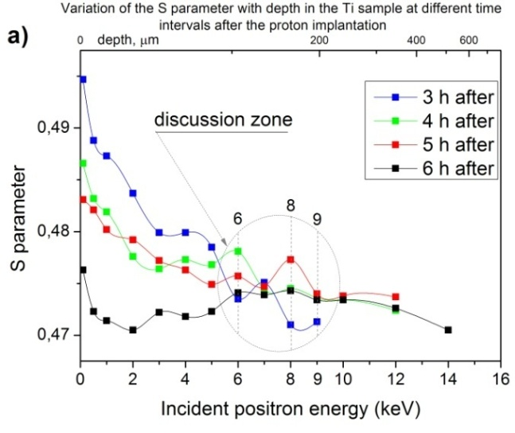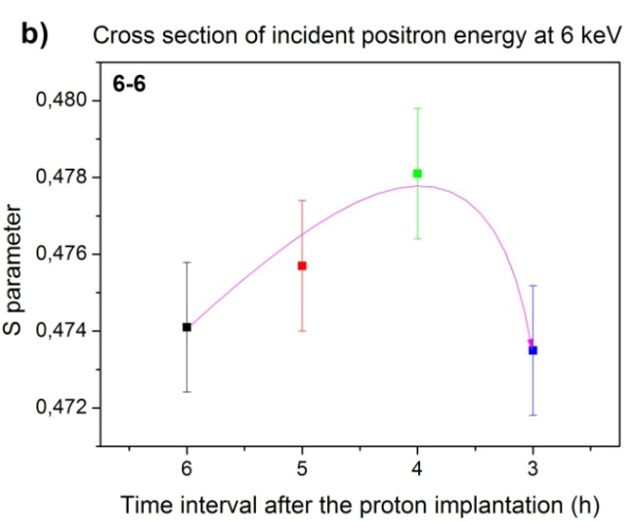

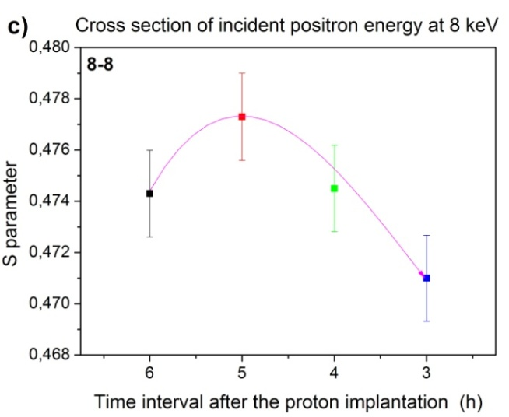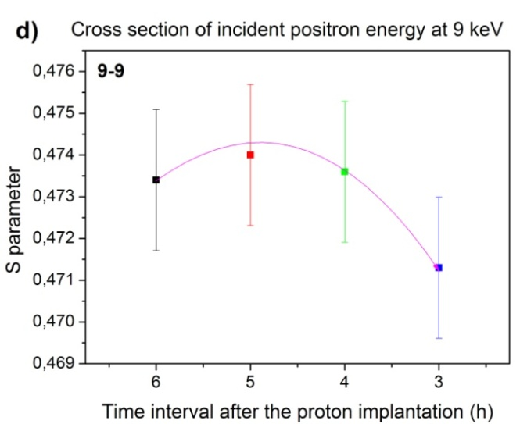

**Figura 1. a)** *Depth analysis of the S parameter, at 3, 4, 5 and 6 hours after proton implantation with a dose of 1018 particles/cm2;* **b), c)** *and* **d)** *cross-sections at 3 different depths, corresponding to 6, 8 and 9 KeV induced positron energy.*

Intentionally in Figure 1 b), c), d) the course of the time characteristic is reversed to make an analogy with the results of the calculations in our previous publication [16]. The main assumption is that the amount of hydrogen in the irradiated sample decreases continuously with time after the implantation process is stopped and the most hydrogen is contained in the volume at the moment when the implantation is stopped. It is visible that the results of the three cross sections that we have chosen at points 6-6, 8-8 and 9-9 demonstrate exactly the effect we are looking for, predicted by the calculations [16]. However, as we mentioned, in the first experiment not all the surrounding factors were taken into account precisely. The implanted protons on the surface of titanium were in the form of a beam with a diameter of ~ 7-8 mm, while the dimensions of our sample are approximately 4 times larger in area. This means that the surface we are studying is unevenly irradiated with protons, and in order to be sure of our results, we need to repeat the experiment with a new sample of appropriate dimensions. At the same time, it was found that such a long implantation (10 days) is a waste, since during the implantation itself there is a leak of hydrogen from the sample and practically continuous implantation within 24 hours (which corresponds to 1017 particles/cm2) is sufficient to provoke the effect we are looking for. We prepared a titanium sample with dimensions of 3x3x5 mm and subjected it to implantation uniformly on the surface with 2 MeV protons. We report the results measured using the positron beam in the discussion below. To have more confidence in the correctness of the experiment, we use information not only for the S parameter but also for the W parameter. To ensure that the experiment proceeds as expected, we performed TRIM calculations to determine the depth of proton deposition (Figure 2). It is apparent that the deposition zones closest to the surface are at about 20 μm, with the main amount accumulating in the region between 60 and 80 μm. As can be seen from Figure 1 a), the depth we investigated with DBS does not exceed 1 μm [34], [35]. For this reason, we can argue that our expectations that hydrogen will move to the surface, passing through the defects in the structure and accumulating in them, are reasonable.

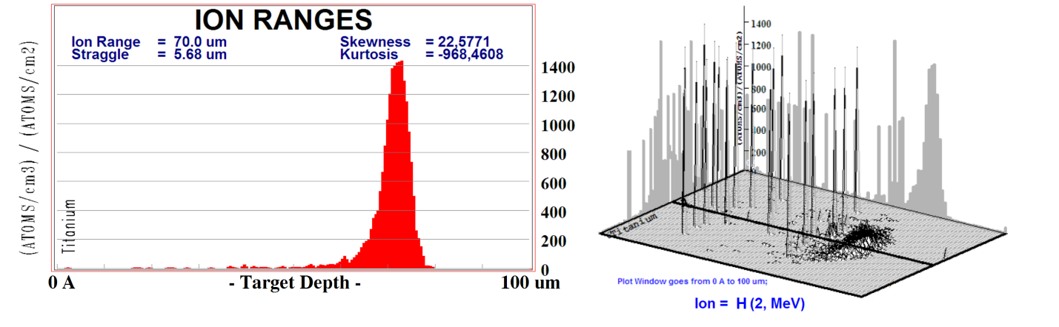

**Figure 2.** *TRIM calculations showing areas of hydrogen deposition with an energy of 2 MeV in a titanium target.* **a)** *2D model cutting the image through the middle zone;* **b)** *3D model describing, additionally, the peak areas of hydrogen deposition.*

From Figure 3. a) we select 5 different sections of the profile of the S and W parameters (5 different points in depth). Apparently there are moments when C and B are not in mirror sequence and there we can talk about an ortho-positronium component [36]. Most of the time, however, a mirror relationship between the two parameters is reported and we discuss these time intervals. In Figure 3 b) corresponding to a depth point of 7 KeV. in the time range between 9 and 6 hours after implantation we can speak of a tendentious decrease in the annihilation with the valence electrons. There is a change in the amount of hydrogen in this volume. Our expectations are that the hydrogen from the deposited volumes has moved to the zone we are considering. In this case, there are two possibilities - either the hydrogen accumulated in this place decreases, as a result of its movement to the surface, or the hydrogen enters into a chemical interaction with itself or with titanium atoms around the defect and thus the contribution of the valence electrons to the annihilation decreases. In the time interval between 6 and 3 hours after proton implantation, we are talking about a local maximum at S and a minimum at W, which at first glance can be interpreted as a picture corresponding to the calculations in our previous publication [16]. If we proceed from the results presented in the work of Weiss et al. [37], we could expect that within the first two hours after implantation the deposited hydrogen will have retreated from its initial position and will have occupied the areas with volume defects from vacancy clusters, as well as the intergranular spaces. The vacuum in the measurement of the Doppler broadening suggests an additional enhancement of the hydrogen flow from the interior of the sample, to the surface. It can be assumed that the flow of hydrogen to the surface follows a stepwise relationship - accumulation in the defects, after the concentration increases sufficiently, the formation of chemical bonds begins and at a certain point the formed hydrogen molecules leave the defect volumes and head towards the surface. After which the process could be repeated. The following sections presented in Figure 3 c), d), e), f) consider just such a possibility.

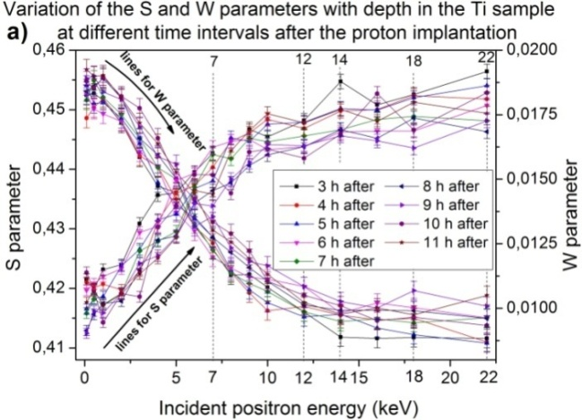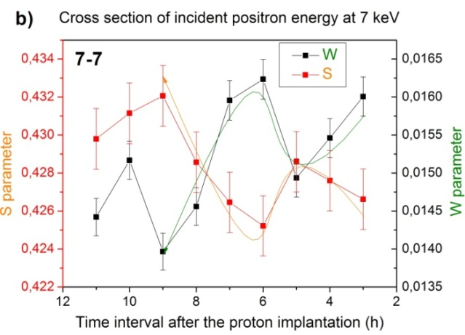

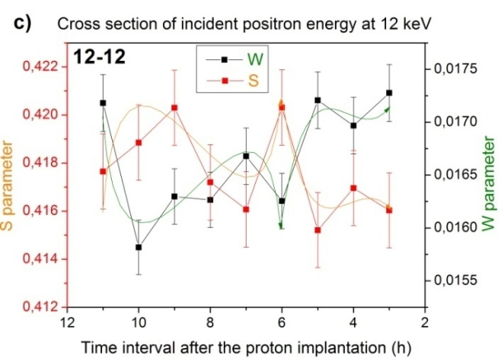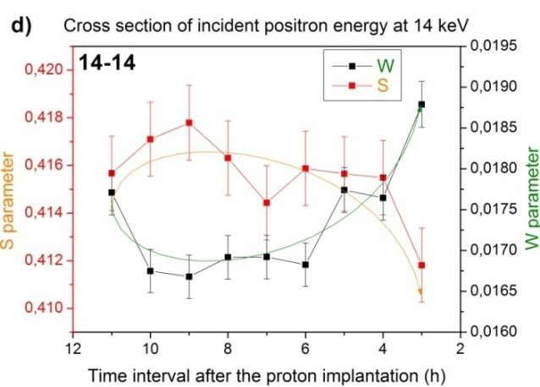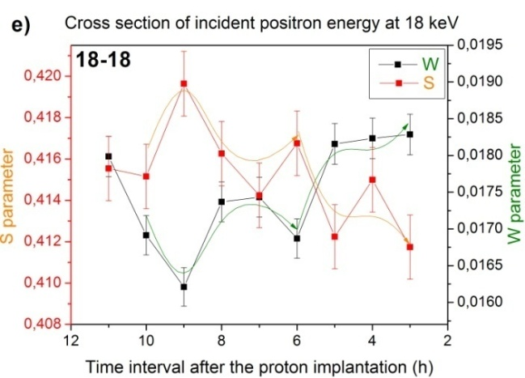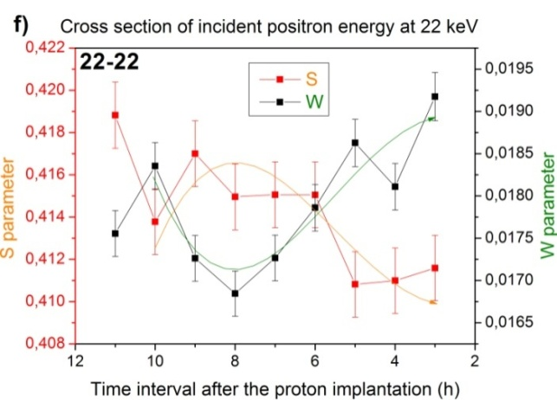

**Figure 3. a)** *Depth analysis of the parameters S and W, at 3, 4, 5, 6, 7, 8, 9, 10 and 11 hours after proton implantation with a dose of 1017 particles/cm2;* **b), c), d), e)** *and* **f)** *cross-sections at 5 different depths, corresponding to 7, 12, 14, 18 and 22 KeV induced positron energy.*

The process described in Figure 3 b) can also be observed in the other cross sections corresponding to induced positron energies of 12, 14, 18 and 22 KeV. In each of the complex cross sections, local extrema and a consistent decrease in chemical bonds with increasing time range after proton implantation can be observed.

These results of ours are confirmed by the work of another team of authors. For example, in the works of Laptev et al., Volokitina (Murashkina) et. al., Lider et. al., Lotkov et. al. Bordulev et. at., [38], [39], [40], [41], [42], [43], [44], [45], [46], [47] it can be seen that with hydrogen saturation in a titanium, zirconium, magnesium, Ti-Ni, Ti-alloy and Zr-Nb base, there are local extrema in the annihilation parameters or their results are consistent with our [13]. Examining in detail the works of Bordulev et al. [48] and Kudiiarov et al. [49], as well as following the logical thread from the introduction to this work of ours, we come to the conclusion that a magnesium base would be more suitable for our research. Continuing the logical sequence, we come to one of the main questions – “Could a better structural configuration be found at the nano level that would optimally determine the solution to the task we have set?”. A similar dilemma is discussed in the work of Kudiiarov et al. [50], from 2023.

From this, we can conclude that there is a collection of hydrogen in molecular form, which allows it to escape unhindered from the interior of the volume to the surface. At the same time, we should note that the participation of hydrogen in a chemical interaction with titanium is associated with the addition of additional energy [51], [52], [53], [54], which practically facilitates our conclusions that chemical bonds are limited mainly to the molecular form of hydrogen.

When we talk about adsorption of the produced hydrogen, we can mention several different methods. Alloys such as TiFeH₂ [28], [55] and Mg₂NiH₄ [27], [56] offer high capacity and reversible storage [57]. On the other hand, the selective permeability of the polymer sites allows for controlled hydrogen release [22], [58]. In this case, we recommend:

- Development of metal hydride-polymer hybrids adapted to extreme environments through material optimization and structural design [59], [60].

- Conducting experimental studies on radiation resistance and thermal cycling resistance [61], [62].

- Investigation of hybrid systems combining cryogenic adsorption with metal hydride-polymer technologies for synergistic benefits [24].

**4. Conclusions:**

- It has been unequivocally confirmed that after proton irradiation of a suitable material we can expect a product H2.

- We can state that in the studied and visible area a cyclic release of the formed molecular structure inside the defects is observed.

- The chemical bonds in the defects are mainly limited to the molecular form of hydrogen.

- Transport to the surface can be unhindered by the use of nano-tubes made of low-valence material.

- In the adsorption of the formed molecular hydrogen, it is recommended to develop a method of metal hydride-polymer hybrids, adapted to extreme environments through material optimization and structural design, in combination with cryogenic adsorption.

# **5. References**

1. Primakov, N. G., Kazarnikov, V. V., Rudenko, V. A., & Gosudarstvennyj Nauchnyj Tsentr Rossijskoj Federatsii - Fiziko-Ehnergeticheskij Inst., Obninsk (Russian Federation). (1995).

2. N. Pushilina, A. Panin, M. Syrtanov, E. Kashkarov, V. Kudiiarov, O. Perevalova, R. Laptev, A. Lider, and A. Koptyug, Metals 8, 301 (2018).

3. E. Stepanova, N. Pushilina, M. Syrtanov, R. Laptev, and E. Kashkarov, International Journal of Hydrogen Energy 44, 29380 (2019).

4. R. Laptev, V. Kudiiarov, and N. Pushilina, Materials Today: Proceedings 19, 2084 (2019).

5. A. M. Lider, V. V. Larionov, S. Xu, and R. S. Laptev, Russ J Nondestruct Test 55, 928 (2019).

6. Y. S. Bordulev, R. S. Laptev, V. N. Kudiiarov, and A. M. Lider, AMR 880, 93 (2014).

7. R. S. Laptev, Y. S. Bordulev, V. N. Kudiiarov, A. M. Lider, and G. V. Garanin, AMR 880, 134 (2014).

8. A. A. Mikhaylov, T. S. Priamushko, M. N. Babikhina, V. N. Kudiiarov, R. Heller, R. S. Laptev, and A. M. Lider, Applied Surface Science 432, 85 (2018).

9. E. N. Stepanova, G. P. Grabovetskaya, I. P. Mishin, A. D. Teresov, and M. S. Syrtanov, in (Tomsk, Russia, 2018), p. 020295.

10. I. P. Mishin, G. P. Grabovetskaya, E. N. Stepanova, R. S. Laptev, and A. D. Teresov, Russ Phys J 62, 854 (2019).

11. R. Laptev, D. Krotkevich, A. Lomygin, E. Stepanova, N. Pushilina, E. Kashkarov, A. Doroshkevich, A. Sidorin, O. Orlov, and V. Uglov, Metals 13, 903 (2023).

12. N. S. Pushilina, V. N. Kudiiarov, R. S. Laptev, A. M. Lider, and A. D. Teresov, Surface and Coatings Technology 284, 63 (2015).

13. E. Kashkarov, N. Nikitenkov, A. Sutygina, R. Laptev, Y. Bordulev, A. Obrosov, M. O. Liedke, A. Wagner, A. Zak, and S. Weiβ, Journal of Alloys and Compounds 732, 80 (2018).

14. I. Bordulev, R. Laptev, V. Kudiiarov, R. Elman, A. Popov, D. Kabanov, I. Ushakov, and A. Lider, Materials 15, 1823 (2022).

15. R. Laptev, A. Lomygin, D. Krotkevich, M. Syrtanov, E. Kashkarov, Y. Bordulev, K. Siemek, and A. Kobets, Metals 10, 535 (2020).

16. E. Popov, T. Troev, L. Petrov, K. Berovski, S. Peneva, and B. Kolev, (n.d.).

17. M. López, Á. Morales-García, F. Viñes, and F. Illas, ACS Catal. 11, 12850 (2021).

18. T. Deschamps, M. Kanniche, L. Grandjean, and O. Authier, Clean Technol. 4, 258 (2022).

19. J. Xiao, A. Mei, W. Tao, S. Ma, P. Bénard, and R. Chahine, Energies 14, 2450 (2021).

20. S. Tibus, J. Klier, and P. Leiderer, J Low Temp Phys 142, 83 (2006).

21. Y. Chen and H. Ahn, Front. Chem. Eng. 3, 742963 (2021).

22. A. Garg, M. Almáši, D. Rattan Paul, E. Poonia, J. R. Luthra, and A. Sharma, Front. Energy Res. 8, 604735 (2021).

23. S.-Y. Lee, J.-H. Lee, Y.-H. Kim, J.-W. Kim, K.-J. Lee, and S.-J. Park, Processes 10, 304 (2022).

24. K.-J. Jeon, H. R. Moon, A. M. Ruminski, B. Jiang, C. Kisielowski, R. Bardhan, and J. J. Urban, Nature Mater 10, 286 (2011).

25. V. Bérubé, G. Radtke, M. Dresselhaus, and G. Chen, Int. J. Energy Res. 31, 637 (2007).

26. J.-C. Crivello, B. Dam, R. V. Denys, M. Dornheim, D. M. Grant, J. Huot, T. R. Jensen, P. De Jongh, M. Latroche, C. Milanese, D. Milčius, G. S. Walker, C. J. Webb, C. Zlotea, and V. A. Yartys, Appl. Phys. A 122, 97 (2016).

27. K. S. Nivedhitha, T. Beena, N. R. Banapurmath, M. A. Umarfarooq, V. Ramasamy, M. E. M. Soudagar, and Ü. Ağbulut, International Journal of Hydrogen Energy 61, 1259 (2024).

28. M. V. Lototskyy, M. W. Davids, I. Tolj, Y. V. Klochko, B. S. Sekhar, S. Chidziva, F. Smith, D. Swanepoel, and B. G. Pollet, International Journal of Hydrogen Energy 40, 11491 (2015).

29. M. López, Á. Morales-García, F. Viñes, and F. Illas, ACS Catal. 11, 12850 (2021).

30. M. N. Mirzayev, E. D. Mustafayev, I. I. Mustafayev, D. M. Mirzayeva, T. T. Thabethe, E. S. Teymurov, N. A. Huseynov, and S. F. Samadov, Radiation Physics and Chemistry 224, 112008 (2024).

31. S. F. Samadov, N. V. M. Trung, A. A. Donkov, A. A. Sidorin, O. S. Orlov, E. Demir, O. A. Samedov, S. H. Jabarov, N. V. Tiep, E. P. Popov, and M. N. Mirzayev, Journal of Nuclear Materials 599, 155242 (2024).

32. L. M. Ledo Pereda, V. N. Semenov, V. S. Rikhvitsky, A. N. Likhachev, R. Sh. Isaev, I. A. Chepurchenko, A. S. Doroshkevich, and V. A. Alexandrov, Phys. Part. Nuclei Lett. 21, 938 (2024).

33. P. Horodek, A. G. Kobets, I. N. Meshkov, A. A. Sidorin, and O. S. Orlov, Nukleonika 60, 725 (2015).

34. P. J. Schultz and K. G. Lynn, Rev. Mod. Phys. 60, 701 (1988).

35. A. P. Mills and R. J. Wilson, Phys. Rev. A 26, 490 (1982).

36. R. S. Brusa, C. Macchi, S. Mariazzi, and G. P. Karwasz, Acta Phys. Pol. A 107, 702 (2005).

37. Z. Weiss, J. Čapek, Z. Kačenka, O. Ekrt, J. Kopeček, M. Losertová, and D. Vojtěch, J. Anal. At. Spectrom. 39, 996 (2024).

38. R. Laptev, A. Lider, Yu. Bordulev, V. Kudiiarov, and G. Garanin, Journal of Alloys and Compounds 645, S193 (2015).

39. T. Murashkina, R. S. Laptev, V. N. Kudiiarov, D. V. Gvozdyakov, and M. N. Babihina, DDF 373, 317 (2017).

40. R. Laptev, E. Stepanova, A. Lomygin, D. Krotkevich, A. Sidorin, and O. Orlov, Metals 14, 452 (2024).

41. A. M. Lider, O. V. Husaeva, Y. S. Bordulev, R. S. Laptev, and V. N. Kudiiarov, AMR 1085, 328 (2015).

42. A. Lotkov, V. Grishkov, R. Laptev, Y. Mironov, D. Zhapova, N. Girsova, A. Gusarenko, E. Barmina, and O. Kashina, Materials 15, 4298 (2022).

43. I. Bordulev, R. Laptev, D. Kabanov, I. Ushakov, V. Kudiiarov, and A. Lider, Materials 14, 6693 (2021).

44. R. S. Laptev, A. M. Lider, Y. S. Bordulev, V. N. Kudiiarov, and D. V. Gvozdyakov, KEM 683, 256 (2016).

45. I. Bordulev, V. Kudiiarov, L. Svyatkin, M. Syrtanov, E. Stepanova, J. Čížek, M. Vlček, K. Li, R. Laptev, and A. Lider, Journal of Alloys and Compounds 798, 685 (2019).

46. R. S. Laptev, A. M. Lider, Y. S. Bordulev, V. N. Kudiiarov, G. V. Garanin, W. Wang, and P. V. Kuznetsov, DDF 365, 232 (2015).

47. R. S. Laptev, V. N. Kudiiarov, Y. S. Bordulev, A. A. Mikhaylov, and A. M. Lider, Progress in Natural Science: Materials International 27, 105 (2017).

48. I. Bordulev, R. Laptev, V. Kudiiarov, R. Elman, A. Popov, D. Kabanov, I. Ushakov, and A. Lider, Materials 15, 1823 (2022).

49. V. N. Kudiiarov, A. Kenzhiyev, R. R. Elman, N. Kurdyumov, I. A. Ushakov, A. V. Tereshchenko, R. S. Laptev, M. A. Kruglyakov, and P. I. Khomidzoda, Metals 15, 72 (2025).

50. V. Kudiiarov, R. Elman, N. Kurdyumov, and R. Laptev, Journal of Alloys and Compounds 953, 170138 (2023).

51. A. Lider, V. Kudiiarov, E. Kashkarov, M. Syrtanov, T. Murashkina, A. Lomygin, I. Sakvin, D. Karpov, and A. Ivanov, Metals 10, 880 (2020).

52. A. López-Suárez, Nuclear Instruments and Methods in Physics Research Section B: Beam Interactions with Materials and Atoms 436, 198 (2018).

53. S. Szmukler‐Moncler, M. Bischof, R. Nedir, and M. Ermrich, Clinical Oral Implants Res 21, 944 (2010).

54. T. Wang, D. Grambole, R. Grötzschel, F. Herrmann, U. Kreißig, F. Eichhorn, G. Brauer, and W. Möller, Surface and Coatings Technology 158–159, 139 (2002).

55. E. M. Dematteis, N. Berti, F. Cuevas, M. Latroche, and M. Baricco, Mater. Adv. 2, 2524 (2021).

56. A. Alaoui-Belghiti, A. Assila, I. Belkoufa, M. Rkhis, S. Laasri, M. Tlemçani, E. Hlil, and A. Hajjaji, International Journal of Hydrogen Energy 92, 1069 (2024).

57. A. Alaoui-Belghiti, A. Assila, I. Belkoufa, M. Rkhis, S. Laasri, M. Tlemçani, E. Hlil, and A. Hajjaji, International Journal of Hydrogen Energy 92, 1069 (2024).

58. M. Tian, S. Rochat, K. Polak-Kraśna, L. T. Holyfield, A. D. Burrows, C. R. Bowen, and T. J. Mays, Adsorption 25, 889 (2019).

59. L. Liu, A. Ilyushechkin, D. Liang, A. Cousins, W. Tian, C. Chen, J. Yin, and L. Schoeman, Inorganics 11, 181 (2023).

60. J.-C. Crivello, B. Dam, R. V. Denys, M. Dornheim, D. M. Grant, J. Huot, T. R. Jensen, P. De Jongh, M. Latroche, C. Milanese, D. Milčius, G. S. Walker, C. J. Webb, C. Zlotea, and V. A. Yartys, Appl. Phys. A 122, 97 (2016).

61. C. Alves, G. Castro, R. Coelho, and L. Hocevar, in *Hydrogen Technologies - Advances, Insights, and Applications*, edited by Z. Abdallah and N. Aldoumani (IntechOpen, 2024).

62. V. Bérubé, G. Radtke, M. Dresselhaus, and G. Chen, Int. J. Energy Res. 31, 637 (2007).