

JOINT INSTITUTE FOR NUCLEAR RESEARCH
Dzhelepov Laboratory of Nuclear Problems

FINAL REPORT ON THE
INTEREST PROGRAMME

Analysis and interactive visualization of neutrino event topologies registered in the OPERA experiment

Supervisor:
Dr. Sergey Dmitrievsky

Student:
Lokesh Kumar Sridhar, India
Vellore Institute of Technology

Participation period:
February 08 – March 19, Wave 3

Dubna, 2021

ACKNOWLEDGEMENT:

First and foremost, I am extremely grateful to my supervisor, Dr. Sergey Dmitrievsky for his invaluable lectures, continuous support, and patience during the course of the research project. I would like to thank the JINR University Center and the INTEREST team for have me as a part of their prestigious INTEREST program, for their technical support and for organizing welcoming lectures which were very helpful to me in getting to know more about various opportunities for students at JINR.

Abstract:

In this project, neutrino event topologies have been addressed and multiple analysis and visualization techniques have been implemented. The OPERA experiment has discovered the transformation of muon neutrinos into tau neutrinos along their flight from CERN to the INFN Gran Sasso laboratory where ten tau neutrino candidates were observed. The corresponding data samples utilized in this project are from this experiment available through the CERN Open Data Portal. The report discusses events divided into three tasks based on analysis of factors such as flight lengths, impact parameters, track multiplicities and reconstructed angles. The interactive patterns and visualization have been scripted in C++ with the help of ROOT framework.

Introduction:

Approximately five decades ago, flavor switches between neutrino species were modeled [1]. The results from the Super-Kamiokande project in 1998 revealed a significant deficiency of atmospheric muon neutrinos, which was viewed as the product of certain conversions [2]. Through years of actual and geochemical studies [3], the solar neutrino paradox may now be understood in the context of neutrino oscillations in the existence of the MSW effect [4] in the Sun's matter. At accelerator-based prolonged benchmark observations [5], the absence of in atmospheric neutrinos [6] was verified. The emergence of neutrinos from oscillations, which would be associated with the vanishing effects, has yet to be observed. The OPERA experiment was capable of identifying the existence of a tiny vτ part in a beam [7]. The possibility that the νµ → νe oscillation may not be the primary cause of the deficiency of vμ was also identified by atmospheric ve levels measurements [8] in the late 1990s, and validated by nuclear reactor studies at small benchmarks.

The OPERA experiment [9] was planned to identify tau leptons formed in ντ charged current (CC) interactions to examine vμ → ντ oscillations in the CERN to Gran Sasso (CNGS) beam [10]. As a hallmark of the lepton, the test searched for neutrino encounters through one secondary short-lived particle. In 2015, OPERA revealed the detection of emergence of a muon neutrino beam [11], which was later increased to a magnitude of 6.1 from its latest sample data [12].

The unique characteristic of ντ encounters with the final-state particle decay in one (muon, electron, or hadron) or three prongs is used to track vμ → ντ oscillations. Incident configuration and kinematics can be thoroughly reproduced with regards to a high (~1 μm) spatial resolution of nuclear emulsions intermixed with lead plates to create a portable modular target, and then using the comparative details given by digital detectors [13]. Nuclear emulsions are excellent detection instruments for the research of short-lived particle decays. They were effectively used throughout the DONUT test [14] at FNAL, which provided the first experimental proof of the tau neutrino [15], as well as in the CHORUS experiment [16], which examined vμ → ντ oscillations at high values of Δm² [17] and studied -driven charm formation, accumulating a sample of over 2000 encounters with a charmed particle in the final form [18].

Dilepton studies in calorimeter detectors [19] and detection of charm decay topologies in nuclear emulsions [20] have also been used to investigate charm hadron production in neutrino interactions. Emulsion-based projects allow for a highly accurate recreation of the case configuration, resulting in a background reduction of 104 times [21]. Background is created by pions and kaons decaying in flight or hadron interactions that do not result in apparent nuclear break-up.

In the OPERA detector's target, a significant muon-less occurrence with two secondary vertices was identified. Both nodes can be viewed as heavy particle decays with a limited lifetime. At the CNGS energy, such an occurrence will arise either from a vτ CC relationship with charm creation or an NC relationship with cc production. The first mechanism is predicted by the Standard Model, but it has never been properly understood, while the CHORUS test discovered three cc-producing events in NC interactions. In OPERA, the predicted amount of such occurrences is less than one.

Background:

The research of charmed particles is still a daunting area of particle physics, nearly 40 years after the introduction of the charm quark at SLAC [22] and BNL [23], as well as the first detection of charm decay in nuclear emulsion [24]. Neutrino-induced charm creation, in specific, allows researchers to investigate the nucleon's strange-quark composition by calculating the CKM matrix factor Vcd "directly" and putting formulas for charm production and eventual hadronization to the examination. Furthermore, neutrinos generate charmed hadrons by complex processes including quasi-elastic and diffractive scattering, providing a one-of-a-kind instrument for studying specific charm creation.

In neutrino oscillation studies where the pulse is provided by the output of a lepton or muons of seemingly ‘wrong' charge with reference to that predicted through neutrino beam helicity, such as in existing studies [25] and at potential neutrino facilities [26], an enhanced understanding of charm generation aims at understanding the charm context.

The E531 [27] test at FNAL was the first to use a hybrid nuclear emulsion detector. The various charmed particles in nuclear emulsion are classified based on their decay configuration and short flight duration, allowing for very loose kinematic cuts. All decay pathways, not just muonic ones, are thus observed with very low history and without the need for awareness of muonic branching ratios. The CHORUS experiment [28] overcame the drawback of low figures often obtained in emulsion studies (122 charm events found in E531) by using a huge (770 kg) nuclear emulsion objective and automatic emulsion scanning [29,30]. As a result, a high-statistics study of charm decays in emulsion was obtained, which is more than one order of magnitude greater than in E531.

The CHORUS experiment used data from the CERN Large Band Neutrino Beam [31], which mostly comprised of muon neutrinos, from 1994 to 1997. The results presented here are based on a thorough observation of the entire CHORUS sample of 2013 charm cases. Full examination identified 1048 activities as being caused by the development of the neutral charmed hadron D⁰ and 965 activities as being caused by the development of the charged charmed hadron 3+ c, D+, or D+ s.
Methods:

The corresponding data samples, published on the Open Data Portal, were extracted from the official OPERA data repository and supplemented with detailed descriptions. The experiments have been divided into three tasks which have been mentioned in the section below along with the methodologies implemented towards their execution.

For task 1, the OPERA emulsion dataset for the neutrino-induced charmed hadron production studies is used to study the positions of the primary and the secondary interaction vertices as well as the parameters of the charm decay daughter particle tracks.
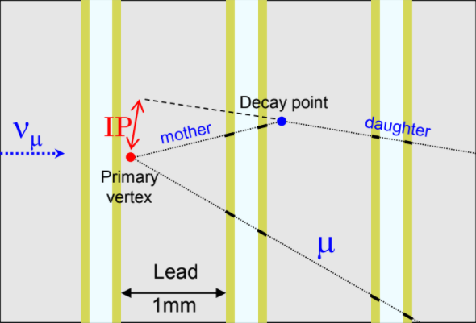
The flight length (or decay length) of a charmed hadron is defined as the distance between the primary and the secondary vertices of the neutrino interaction event, i.e., the distance between two points in 3d space.
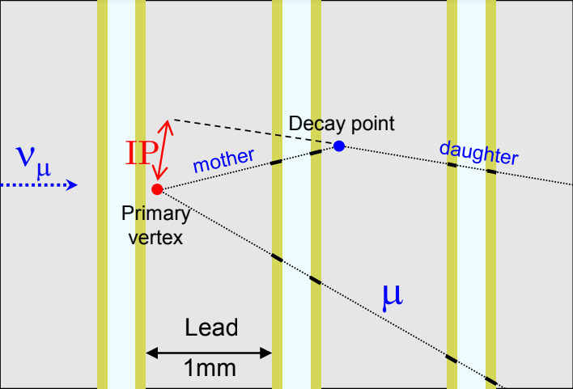

Fig. 1. Distance between vertices of neutrino interaction event

The second sub-task focuses on the study of the impact parameters of the daughter particle tracks with respect to the primary neutrino interaction vertex. Impact parameter (IP) is defined as the distance between the daughter particle track and the primary neutrino interaction vertex, i.e., the distance between a line and a point in 3d space.
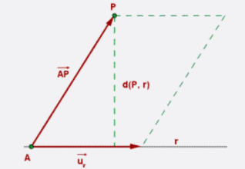
Fig. 2. Calculation of distance in a 3-D environment

For calculation in 3d space, the distance from a point P, to a line r, is the smallest distance from the point to one of the infinite points on the line. The distance corresponds to the perpendicular line from the point to the line. As shown in fig. 2., the distance from a point P, to a line r, is defined by:

$$d\left(P,r\right)=\vec{u_{r}}x\vec{AP}∨\frac{}{\vec{u_{r}}∨}$$

For task 2, the OPERA emulsion dataset for the charged hadron multiplicity studies has been implemented. The task studies the positions of the primary neutrino-lead interaction vertices as well as the parameters of the secondary charged particle tracks. Track multiplicity is defined as the number of tracks (of charged particles) associated with a given vertex (in our case – with the vμ primary interaction vertex). In the multiplicity sample each track is defined by its starting point (a 3d point near the vertex) and two slopes: slopeXZ and slopeYZ (i.e., tangents of angles with respect to the Z axis in the XZ and YZ views) given in the dataset. In this task we will save the track multiplicities to a 1-dimentional histogram, while the two angles of muons to a 2-dimentional histogram.

For task 4, the OPERA emulsion dataset for the tau neutrino appearance studies has been implemented. The task requires development of a browser-based 3D event display which can be used to show tracks and vertices reconstructed in nuclear emulsions of the 10 tau neutrino candidate events. The web application is developed with the help of the three.js graphics library.

Results:

The tasks were successfully executed using code written in the C++ programming language along with ROOT data analysis framework for interactive visualization of the results. The development of the web application for task 4 has been implemented with the help of HTML, CSS and JavaScript graphic libraries such as D3.js and three.js specifically for visualization of typical topologies in neutrino interaction events.

As shown in Fig. 3., resulting histograms obtained in our analysis are comparable with the histograms presented by Agafonova et al. [32], which display the correlation of flight length with number of events and impact parameter with number of tracks.

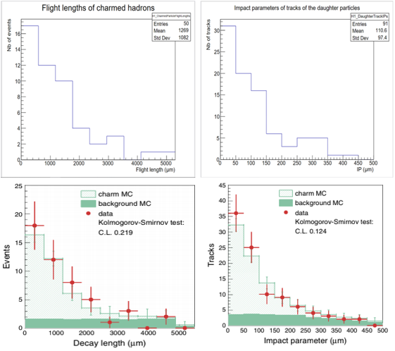

Fig. 3. Left distribution of flight length of charmed particles by author (Above), Left distribution of flight length of charmed particles by Agafonova et al. (Below)

As shown in Fig. 4., resulting histograms obtained in analysis are comparable with the histograms presented by Agafonova et al. [33], which display the correlation of track multiplicities and number of events. A 3-d representation of the muon track angles has also been implemented.

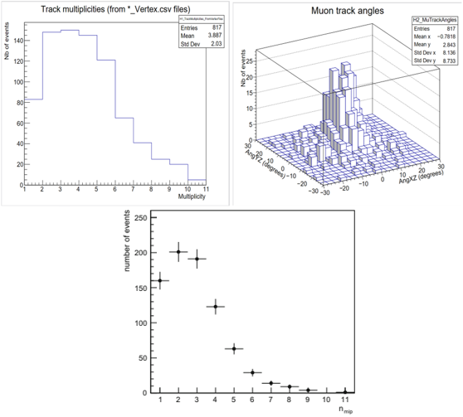

Fig. 4. Track multiplicities distribution by author, muon angle representation in 3-D, Track multiplicities distribution by Agafonova et al. (Clockwise)

In the task 4, a browser-based event display has been successfully developed with use of JavaScript for interactive visualization of OPERA tau neutrino candidate events. As shown in Fig. 5., the web application displays 3D tracks reconstructed in emulsion.

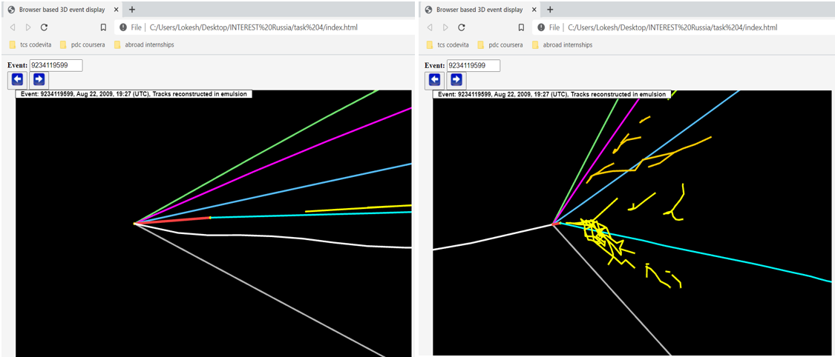

Fig. 5. Visualization of track reconstruction in emulsion using web browser

Conclusion:

The successful completion of the tasks of the project made it possible to better understand how to find and read datasets from CERN Open Data Portal and how to analyze the features of different neutrino event topologies. The obtained histograms and the developed 3D event display can be used, for example, as templates for future scientific analysis applications. The comparison between the obtained results and the previous studies adds validation to several relevant variables and opens up more opportunities for further research.

References:
- Z. Maki, M. Nakagawa and S. Sakata, Remarks on the unified model of elementary particles, Prog. Theor. Phys. 28 (1962) 870
- Super-Kamiokande collaboration, R. Wendell et al., Atmospheric neutrino oscillation analysis with sub-leading effects in Super-Kamiokande I, II and III, Phys. Rev. D 81 (2010)
- KamLAND collaboration, S. Abe et al., Precision measurement of neutrino oscillation parameters with KamLAND, Phys. Rev. Lett. 100 (2008) 221803
- A.Y. Smirnov, The MSW effect and matter effects in neutrino oscillations, Phys. Scripta T 121 (2005) 57
- MINOS collaboration, P. Adamson et al., Search for active neutrino disappearance using neutral-current interactions in the MINOS long-baseline experiment, Phys. Rev. Lett. 101 (2008) 221804
- Soudan-2 collaboration, W. Allison et al., Neutrino oscillation effects in Soudan-2 upward-stopping muons, Phys. Rev. D 72 (2005) 052005
- OPERA collaboration, An appearance experiment to search for νµ → ντ oscillations in the CNGS beam: experimental proposal, CERN-SPSC-2000-028
- Palo Verde collaboration, A. Piepke, Final results from the Palo Verde neutrino oscillation experiment, Prog. Part. Nucl. Phys. 48 (2002) 113
- N. Agafonova et al., JINST 4(06), P06020 (2009). https://doi.org/ 10.1088/1748-0221/4/06/P06020
- R. Bailey et al., The CERN Neutrino beam to Gran Sasso (NGS). Tech. Rep. CERN-SL-99-034-DI. INFN-AE-99-05, CERN, Geneva (1999). http://cds.cern.ch/record/390779. Addendum to report CERN 98-02, INFN-AE-98-05
- N. Agafonova et al., Phys. Rev. Lett. 115, 121802 (2015). https:// doi.org/10.1103/PhysRevLett.115.121802
- N. Agafonova et al., Phys. Rev. Lett. 120(21), 211801 (2018).
- N. Agafonova et al. (OPERA Coll.), JINST 4, P06020 (2009)
- K. Kodama et al. (DONUT Coll.), Nucl. Instrum. Methods A 493, 45 (2002)
- K. Kodama et al., (DONUT Coll.), Phys. Lett. B 504, 218 (2001)
- E. Eskut et al. (CHORUS Coll.), Nucl. Instrum. Methods A 401, 7 (1997)
- E. Eskut et al. (CHORUS Coll.), Nucl. Phys. B 793, 326 (2008)
- A. Kayis-Topaksu et al. (CHORUS Coll.) New J. Phys. 13, 093002 (2011)
- P. Vilain et al., EPJ C 11(1), 19 (1999). https://doi.org/10.1007/ s100529900141
- A. Kayis-Topaksu et al., New J. Phys. 13, 093002 (2011). https:// doi.org/10.1088/1367-2630/13/9/093002
- A. Kayis-Topaksu et al., EPJ C 52, 543 (2007). https://doi.org/10. 1140/epjc/s10052-007-0410-8
- Augustin J E et al 1974 Phys. Rev. Lett. 33 1406
- Aubert J J et al 1974 Phys. Rev. Lett. 33 1404
- Niu K, Mikumo E and Maeda Y 1971 Prog. Theor. Phys. 46 1644
- Acquafredda R et al 2009 JINST 4 P04018
- Gomez-Cadenas J J et al 2002 Physics opportunities at neutrino factories Annu. Rev. Nucl. Part. Sci. 52 253
- Ushida N et al (E531 Collaboration) 1988 Phys. Lett. B 206 375
- Eskut E et al (CHORUS Collaboration) 1997 Nucl. Instrum. Methods A 401 7
- Aoki S et al 1990 Nucl. Instrum. Methods B 51 466
- Nakano T 1997 PhD Thesis Nagoya University, Japan
- Heijne E H M 1983 CERN Yellow Report 83-06
- Agafonova, N., Aleksandrov, A., Anokhina, A., Aoki, S., Ariga, A., Ariga, T., Bender, D., Bertolin, A., Bozza, C., Brugnera, R. and Buonaura, A., 2014. Procedure for short-lived particle detection in the OPERA experiment and its application to charm decays. The European Physical Journal C, 74(8), pp.1-9.
- Agafonova, N., et al. "Study of charged hadron multiplicities in charged-current neutrino–lead interactions in the OPERA detector." The European Physical Journal C 78.1 (2018): 1-8.

